Wilfred Blaize Catoire
December 13, 1931 – December 12, 2014

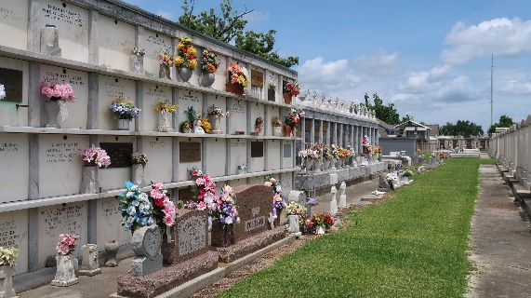

Wilfred "Skinny" Catoire, age 82, was born on December 13, 1931 and passed away peacefully at home on December 12, 2014. He was a native and resident of Reserve, LA.
He is survived by his wife of 56 years, Dolores Schexnayder Catoire; children: Kathy Lonidier (Jeffrey), Mary Beth Catoire, Pam Barker (Patrick), Patty Forsythe (Aaron), and Blaize Catoire (Tina). He is also survived by his grandchildren: Amy Satterlee, John and Jarett Maurin, Megan Stevens, Cody Warner, Ernest and Beth Clement, Christopher and Jennifer Ilski, Karlie Englade, Trey and Ken Catoire, Justin Barker, Chelsea Forsythe, and Jonathan and Benjamin Lonidier and 14 great-grandchildren.
He was preceded in death by his parents Leo and Gladys Madere Catoire, son Kenny Catoire, brothers L. J., George, and Bruce Catoire and sisters, Priscilla Richard and Diana Trosclair.
He was a lifelong member of the VFW Post 159. He loved being with his family, playing golf, deer hunting, fishing, and playing cards at "Daddy's Hideout". He will be greatly missed by all who knew and loved him.
Visitation will be on Monday, December 15, 2014 from 8:30 a.m. until 10:45 a.m. at St. Peter Catholic Church in Reserve, LA followed by a Mass of Christian Burial at 11:00 a.m. Interment will be in the church cemetery. ROSE LYNN FUNERAL SERVICES is in charge of the arrangements.

The New Orleans Advocate, Louisiana
Dec. 13 to Dec. 15, 2014

