Michel Roy Centanni

September 3, 1928 – July 19, 2015

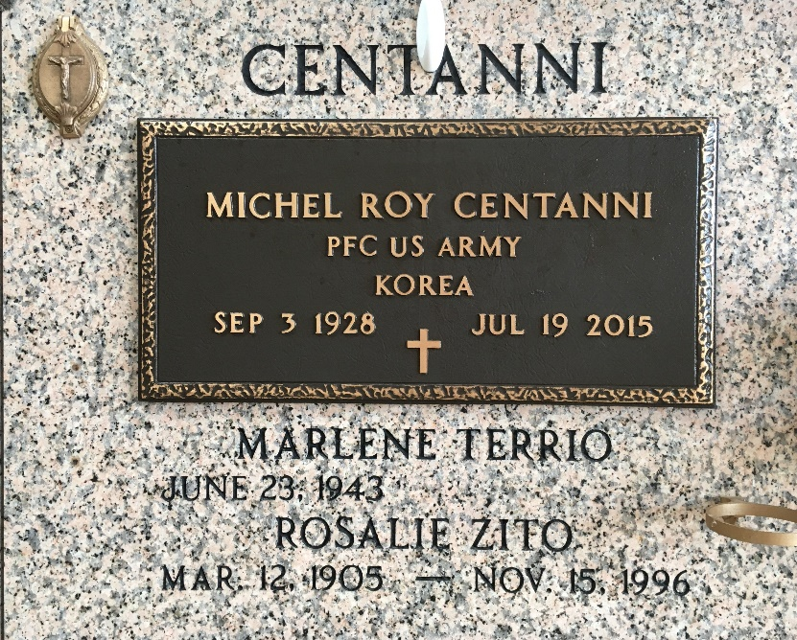

Photo by Team T-Lo

Michel Roy Centanni passed away on Sunday, July 19, 2015.Beloved husband of Marlene Terrio Centanni. Age 86, born in Kenner, Louisiana and a long time resident of Laplace, Louisiana.

Father of Dahlene Centanni (Victor Garcia-Pratts), Michel "Mike" Centanni, Jr. (Janet), Victor Centanni (Kathy), Chad Ayme (Nickie) and Gina Cancienne (Alan. Grandfather of Annette, Rae, Amy, Lea, Jan, Kim, Vonny, Armand, Elias and Noah. He also had 12 great-grandchildren. Godfather of Joseph A. Joffrion, V. Son of the late Rosalino J. Centanni and Rosalie Zito Centanni. Brother of the Marion Centanni Joffrion. He was preceded in death by his first wife Iva Annette Spears Centanni.

Relatives and friends are invited to attend a Mass of Christian Burial at Assension of Our Lord Catholic Church, 1900 Greenwood Dr. Laplace, Louisiana on Thursday July 23, 2015, at 11:30AM. Visitation will begin in church at 9:30 AM. Interment will follow in St. Peter Cemetery, 1550 LA 44, Reserve, Louisiana.

Millet-Guidry Funeral Home, LaPlace, Louisiana