Emile J. Champagne

May 17, 1871 – May 16, 1953

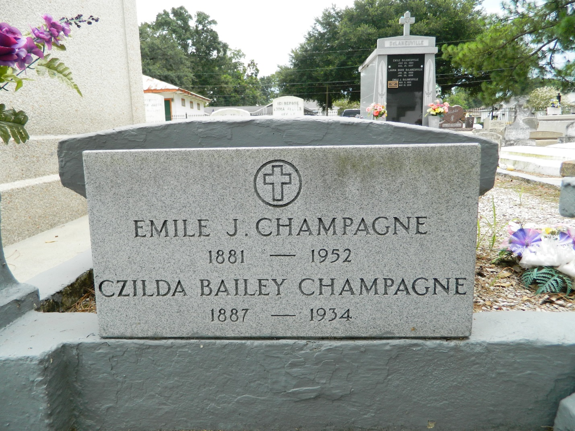

On Saturday May 16, 1853 at 5:30 a.m. Emile Champagne, husband of the late Ezilda Bailey and now Ernestine Schexnayder, father of Mrs. Edna Lackvard of California, Mrs. Tony Marino, Herbert and John of LaPlace, La, Benny of Good Hope, La, Wilson and Emile Jr. Of Bogalusa, La., Step father of; Mrs Walter Taggin, brother of; Louis, Edmond and Leopold La Branche. Age 71.  
  
Relatives and friends of the family are invited to attend the funeral which will take place from Miller's Funeral Home at LaPlace, La on Sunday, May 17, 1953 at 3:30 o'clock p.m. Followed by religious services at St Joan of Ark Church at LaPlace, La. Interment in St. Peters Cemetery, Reserve, La.  
  
Times-Picayune (New Orleans, Louisiana)

Sunday, May 17, 1953, Page: 16