Henry Joseph Champagne Sr.

February 24, 1916 – September 29, 1999

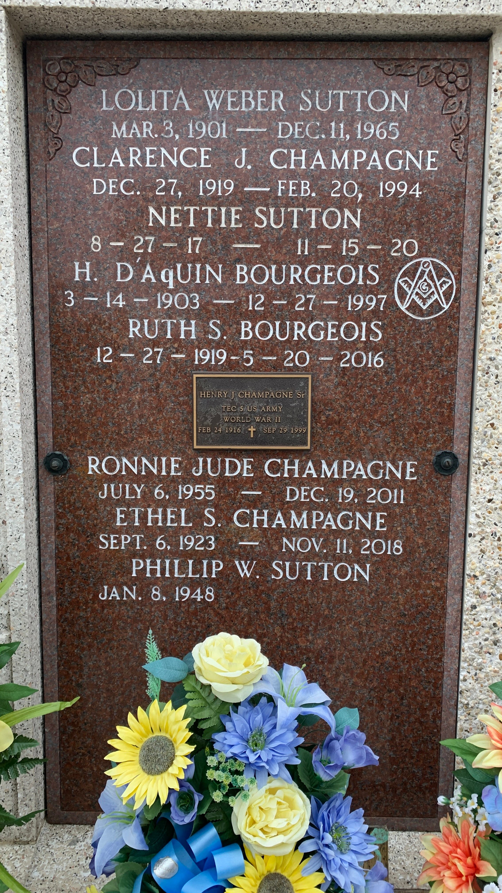

Photo by Team T-Lo

LAPLACE Henry J. Champagne Sr., 83, a native and resident of Mt. Airy, died Sept. 29.

He was the husband of Ethel Sutton Champagne and father of Joycelyn Martinez and Barry, Bryan, Ralph, Michael, Ronnie, David and Henry Champagne Jr. He was also the son of the late Andre and Alice Champagne and brother of Geraldine Berthelot and the late Irving, Clarence, Lloyd and Lawrence Champagne. He is also survived by 13 grandchildren and one great-grandchild.

Services were held Oct. 1 in the chapel of Millet-Guidry Funeral Home, LaPlace with interment at St. Peter Cemetery, Reserve.  
  
L'Observateur, LaPlace, Louisiana

October 2, 1999