John L. Champagne Sr.

May 22, 1939 – October 15, 2020

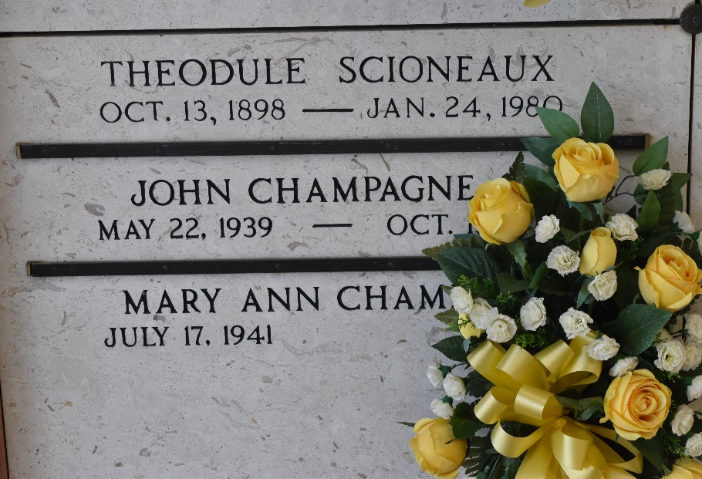

Photo by Team T-Lo

John L. Champagne Sr., a native of LaPlace and resident of Reserve, passed away peacefully on Thursday, October 15, 2020 at the age of 81.  
 He is survived by his wife of 60 years, Mary S. Champagne; children, John L. Champagne Jr., Jodi Stevens (Ronnie) and Jeanne Simmons (Warren III); grandchildren, John L. Champagne III, Jake Stevens, Warren Simmons IV and Justin Simmons; and great-grandchildren, Hunter Champagne and Ella Champagne.  
 He is preceded in death by his grandson, Dillon Simmons; parents, Emile and Ernestine Champagne; and siblings, Wilamenia Tassin and Herbert Champagne Sr.  
 A visitation will be held on Monday, October 19, 2020 at St. Peter Catholic Church from 10:00 AM until service time. A Mass of Christian Burial will take place at 11:00 AM. Interment will follow in the church cemetery.  
 John was an avid sportsman. He also enjoyed participating and watching sporting events. He will be greatly missed by all who knew him.  
  
Rose Lynn Funeral Home, Lutcher, Louisiana