Ronnie Jude Champagne

July 6, 1955 – December 19, 2011

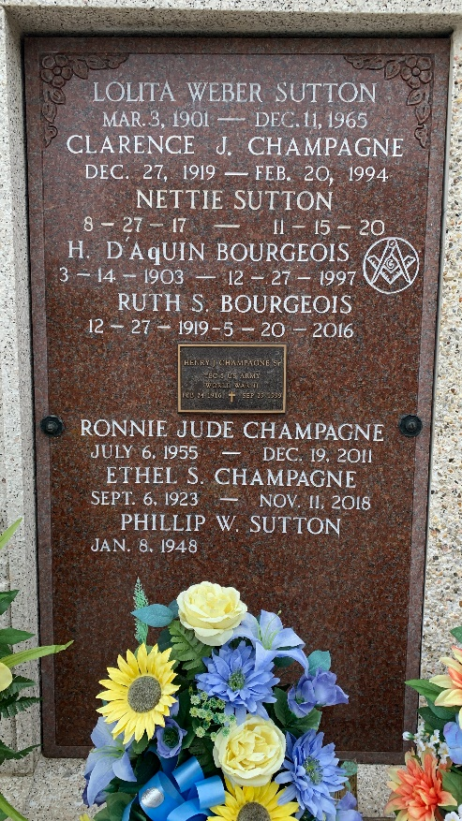

Photo by Team T-Lo

CHAMPAGNE Ronnie J. Champagne passed away on Monday December 19, 2011.  
 Beloved son of Ethel Sutton Champagne and the late Henry Champagne.  
Brother of Barry (Linda), Bryan (Marlen), Ralph (Mary), Mike (Cindy), David (Debbie) and Henry Champagne Jr. (Paula) and Joycelyn Martinez (Nathan)  
Also survived by numerous nieces and nephews.  
 Age 56. A native and resident of Mt. Airy, LA.  
 Relatives and friends are invited to attend services. Visitation at Millet-Guidry Funeral Home 2806 W. Airline Hwy., LaPlace, LA on Thursday December 22, 2011 from 5:00 pm to 6:00 pm, followed by Religious Services in the Funeral Home Chapel at 6:00 pm. Burial to be private at a later date.  
  
The Times-Picayune, New Orleans, Louisiana

Dec. 20 to Dec. 21, 2011