Marguerite (Charrier) Charnet

April 20, 1879 – September 2, 1955

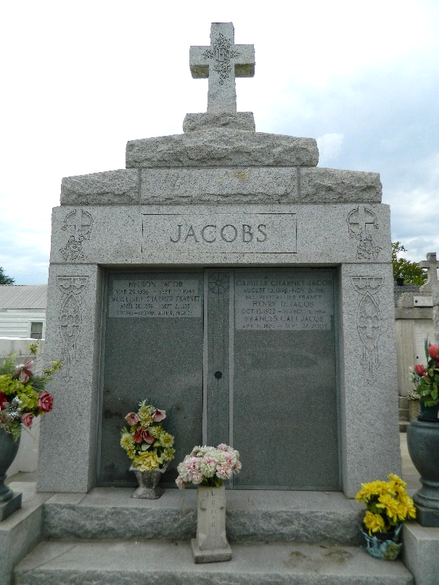 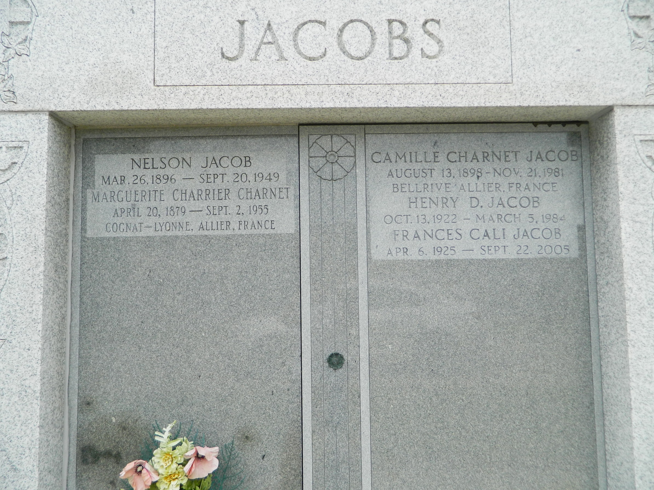

CHARNET – At the residence of her daughter, Mrs. Nelson Jacob, Laplace, La., on Friday, September 2, 1955 at 11 o’clock a.m., Marguerite Charrier, wife of the late Claude Charnet; mother of Mrs. Nelson Joseph and Martha Charnet; also survived by three grandchildren and seven great-grandchildren; aged 76 years; a native of France, and a resident of Laplace, La., for 29 years.

Relatives and friends of the family are invited to attend the funeral, which will take place from Millet Funeral Home, Laplace, La., on Saturday, September 3, 1955 at 4 o’clock p.m., followed by religious services at St. Joan of Arc Church, Laplace, La.

Interment in St. Peter cemetery, Reserve.

The Times-Picayune, New Orleans, Louisiana

Jan. 7, 2003