Lucille M. (Vicknair) Chassaniol

November 5, 1908 – January 5, 2003

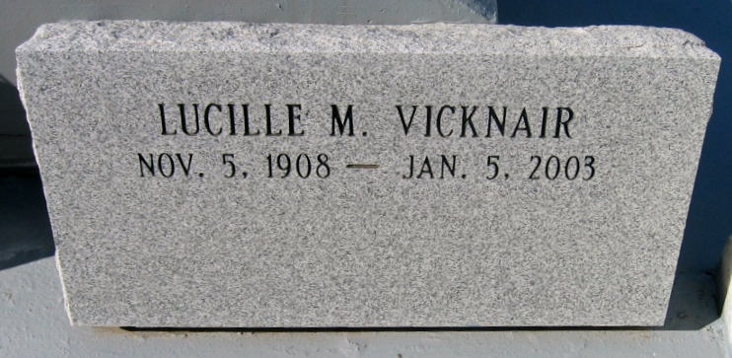

Photo by Bobby

Lucille Vicknair at Metairie, La. on Sunday, January 5, 2003.

Beloved wife of the late Edwin Cecil Chassaniol. Mother of Edwina Rita Mc Cready. Sister of the late Rita Giangrosso and Walter J. Vicknair. Mother-in-law of Dr. James Mc Cready. Also survived by 3 grandchildren: Dr. James M. Mc Cready, Laura Mc Cready Barnes and Stephen Patrick Mc Cready. Great-Grandmother of Kathleen Elizabeth Barnes and Austin Michael Mc Cready.

Relatives and friends of the family are invited to attend the Funeral Mass from the Jefferson Chapel of Tharp Sontheimer Tharp Funeral Home 1600 N. Causeway Blvd. at 43RD St., Metairie, La. on Wednesday, January 8, 2003 at 12:00 o’clock Noon. Interment in St. Peter Catholic Church Reserve, La. Visitation on Wednesday, January 8, 2003 from 10:00 o’clock AM until 12:00 o’clock Noon.

The Times-Picayune, New Orleans, Louisiana

Jan. 7, 2003