Anastasia Marie Chauffe

April 2, 1839 – January 7, 1930

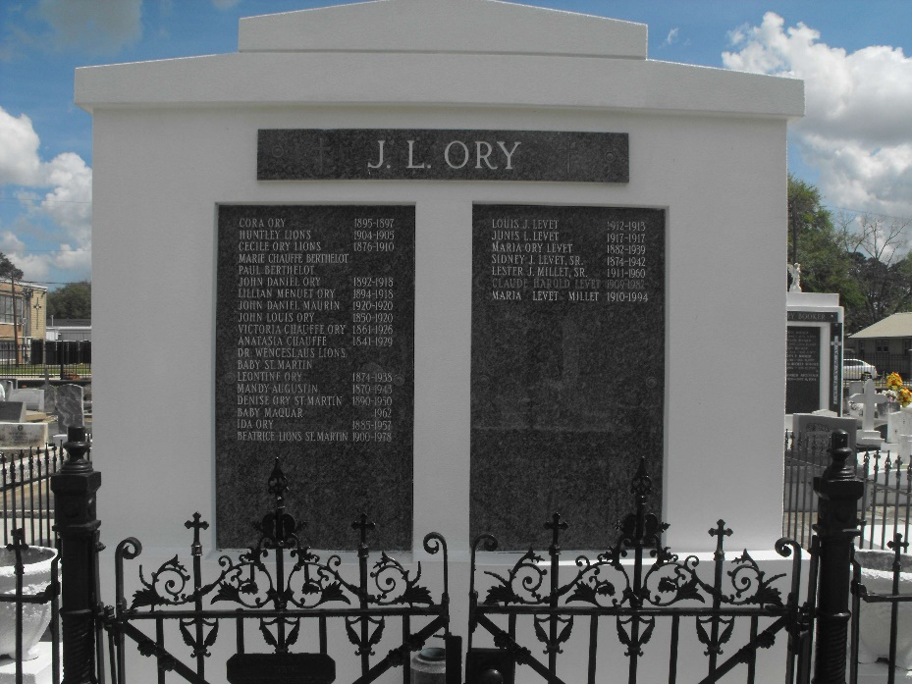 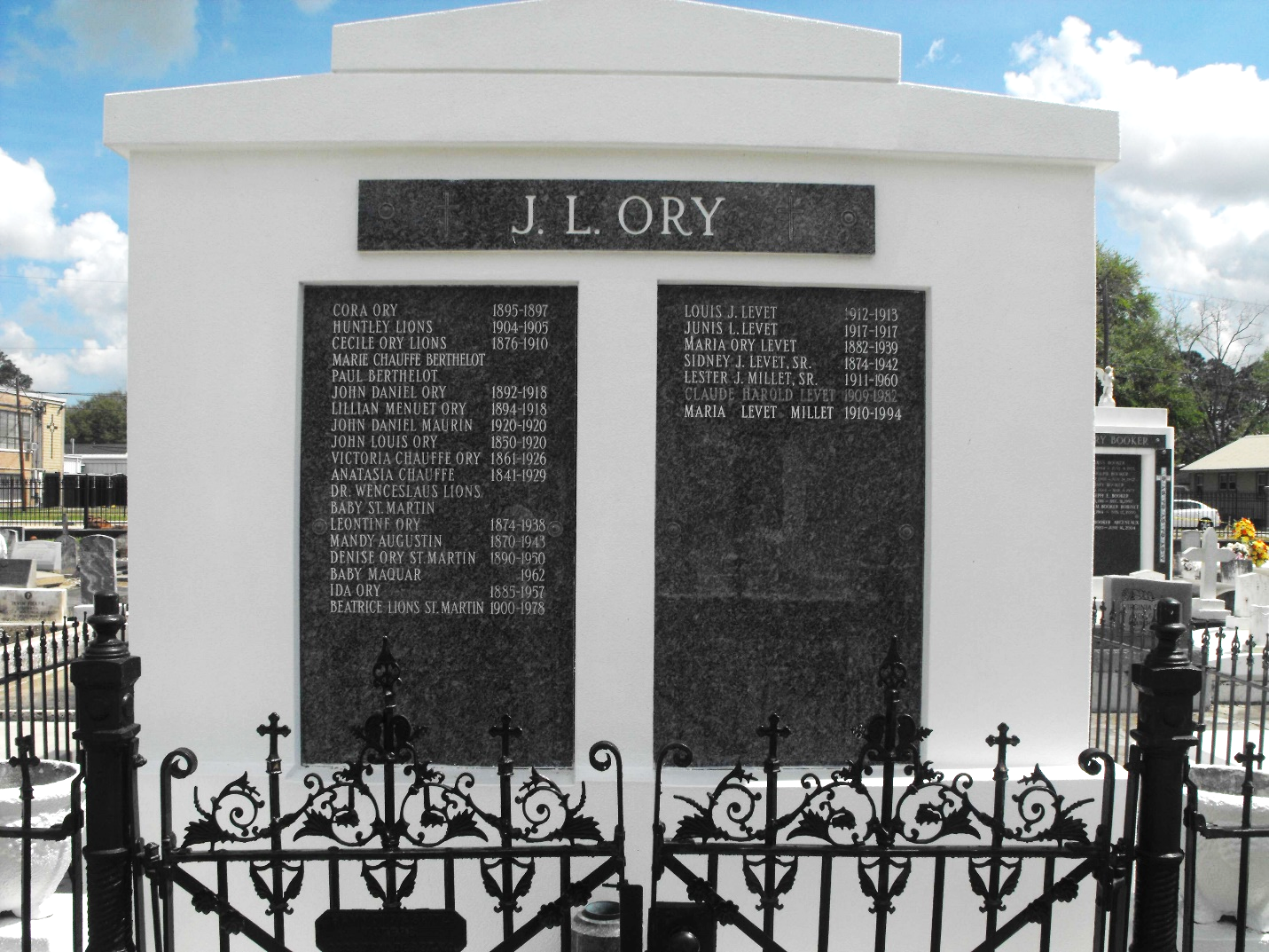

Photo by Mary Agnes Hammett

CHAUFFE – At the residence of her grandnieces, Misses Ory, No. 25 Audubon Blvd., on Tuesday, January 7, 1930, at 8:15 a.m., aged 90 years, Miss Anastasie Chauffe, daughter of the late Jean Louis Chauffe and Marie Amelia Streck, a native of Assumption parish, and a resident of this city for the past 6 years.

The relatives, friends and acquaintances of the family are respectfully invited to attend the funeral which will take place this Wednesday, January 8, 1930, at 7:30 a.m. from the Laudumicy funeral parlors, 1112 N. Rampart street near Ursuline. Mass of requiem at Holy Name of Jesus church (opposite Audubon Park at 8 a.m. Interment in Reserve, La.

New Orleans States Newspaper, Louisiana

Tuesday, January 7, 1930, p. 2