Alcee J. Chenier

December 21, 1934 – March 25, 2013

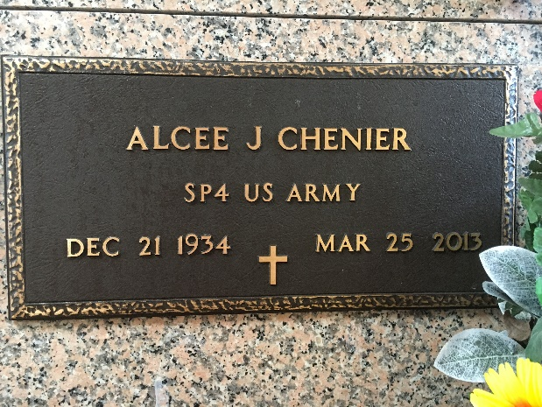

Photo by Team T-Lo

 Alcee J. Chenier entered his heavenly home on Monday March 25, 2013.  
 Beloved husband of Veronica P. Chenier. Father of Gina Duhe (Todd), Amy Lewis (Mike), Angelle Clift (The late Eddie), Candice Snyder (J.R.) and the late Claire Chenier. Grandfather of Tony, Joey, Hayden, Emily, Devin, Dustin, Chase, Austin and Katie. Son of the late J. B. A. and Claire Chenier. Brother of the late Robert (Bobby) Chenier (Katherine).  
 He served in the U.S. Army during the Korean Conflict. Age 78. A native of Reserve, LA and a resident of LaPlace, LA.  
 Relatives and friends and also employees of St. John the Baptist Parish are invited to attend services. Visitation at Millet-Guidry Funeral Home, LaPlace, LA on Monday April 1, 2013 from 5:00pm to 9:00pm and on Tuesday from 8:00am to 10:00am, followed by Mass at Ascension of Our Lord Catholic Church, 1809 Greenwood Dr., LaPlace, LA at 10:30am. Burial in St. Peter Cemetery, Reserve, LA.  
  
The Times-Picayune, New Orleans, Louisiana

March 26 to March 27, 2013.