Claire A. Chenier
May 31, 1968 – October 5, 2009

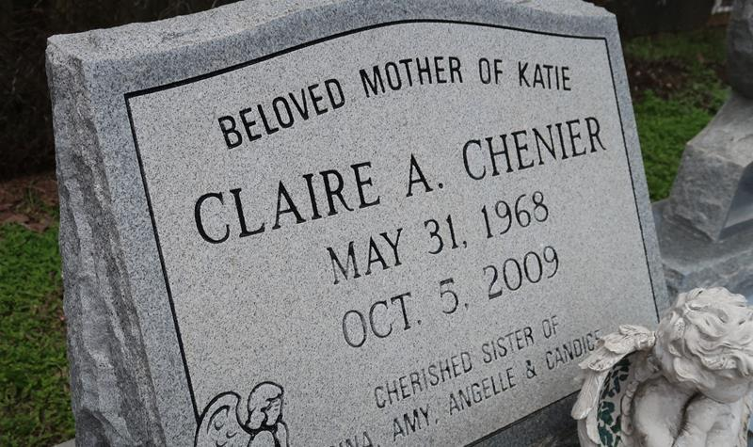

Claire Chenier went to her eternal resting place on Wednesday October 6, 2009 at 6:22 pm. Beloved mother of Katie Chenier. Daughter of Alcee and Veronica Chenier of LaPlace, La. Sister of Gina Duhe and husband Todd, Amy Lewis and husband Mike, Angelle Clift and husband the late Eddie and Candice Snyder and husband J. R. Aunt of Tony, Joey, Hayden, Emily, Devin, Dustin and Chase. Granddaughter of the late J. B. A. and Claire Chenier and Henry and Annie Digirolamo. Age 41. A native and resident of Reserve, La.
Relatives and friends are invited to attend services. Visitation at Millet-Guidry Funeral Home, 2806 W. Airline Hwy., LaPlace, La. on Friday October 9, 2009 from 8:30 am to 10:30 am. Followed by a Mass at St. Peter Catholic Church, Reserve at 11:00 am. Burial in St. Peter Cemetery.
The Times-Picayune, New Orleans, Louisiana
Oct. 8, 2009

