Richard J. Chenier

August 22, 1942 - October 16, 2021

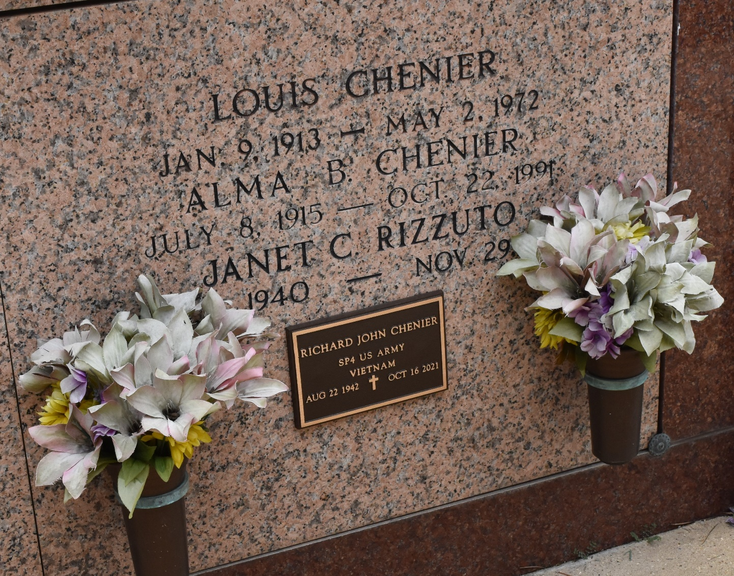

Richard "Dickie" J. Chenier, a Vietnam War Veteran, passed away on Saturday, October 16, 2021 at the age of 79. He was native and lifelong resident of Reserve, LA.

Beloved son of the late Alma Bourgeois Chenier and Louis Chenier. Brother of Joyce C. Petit (Claude), Susan C. Loupe (Norbert) and the late Gerald Chenier (Laura), Donald Chenier (Phyllis) and Janet C. Rizzuto. Also survived by many nieces and nephews.

Relatives and friends are invited to attend the Visitation and Funeral Mass at St. Peter Church, 1550 Hwy 44, Reserve, LA on Wednesday, October 20, 2021. Visitation from 10:00 a.m. to 11:00 a.m. followed by a Funeral Mass at 11:00 a.m. Interment in St. Peter Cemetery.

Millet-Guidry Funeral Home, LaPlace, Louisiana

October 19, 2021