Veronica (Posey) Chenier

September 26, 1944 - May 16, 2021

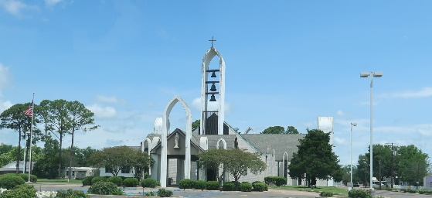

Photo by Team T-Lo

Veronica Posey Chenier joined her Lord and Savior, Jesus Christ on Sunday, May 16, 2021 at the age of 76. She was a resident of LaPlace, LA and a native of Baton Rouge, LA, where she graduated from Redemptorist High School. Her Catholic faith was the strong foundation on which she raised her family. Veronica enjoyed the simplest things in life including shopping, watching TV, cooking, and especially singing and dancing with her family. Her love of music lives on through her children and grandchildren.  
 Beloved wife of the late Alcee Chenier. Loving mother of Gina Duhe (Todd), Amy Lewis (Mike), Claire Chenier (deceased), Angelle Ory (Shannon), and Candice Snyder (Arthur, Jr.). Grandmother of Tony Duhe (Marlee), Joey Duhe (Katie), Hayden Lewis, Emily Rebstock (Michael), Katie Chenier, Devin Clift (Heather), Chase Snyder, and Austin Snyder. Great grandmother of Preston and Parker Duhe. Mother-in-law of the late Edward Clift, III. Daughter of the late Mamie Digirolamo Posey and Sgt. Clarence James Posey. Lovingly raised by her late aunt and uncle, Annie and Henry Digirolamo. Sister of Clarence James Posey, Jr., Vita Taylor (deceased), Mamie Zumo, and Joseph Digirolamo (deceased). Also survived by many nieces and nephews.  
 Relatives and friends are invited to attend the Visitation at Millet-Guidry Funeral Home, 2806 W. Airline Hwy., LaPlace on Wednesday, May 19, 2021 from 5:00 p.m. to 8:00 p.m. and on Thursday, May 20, 2021 from 9:00 a.m. to 10:30 a.m. followed by a Funeral Mass at Ascension of Our Lord Catholic Church, 1900 Greenwood Dr., LaPlace at 11:30 a.m. Interment in St. Peter Cemetery.

Millet-Guidry Funeral Home, LaPlace, Louisiana