Brent Germain Cicet

October 10, 1942 – September 19, 2014

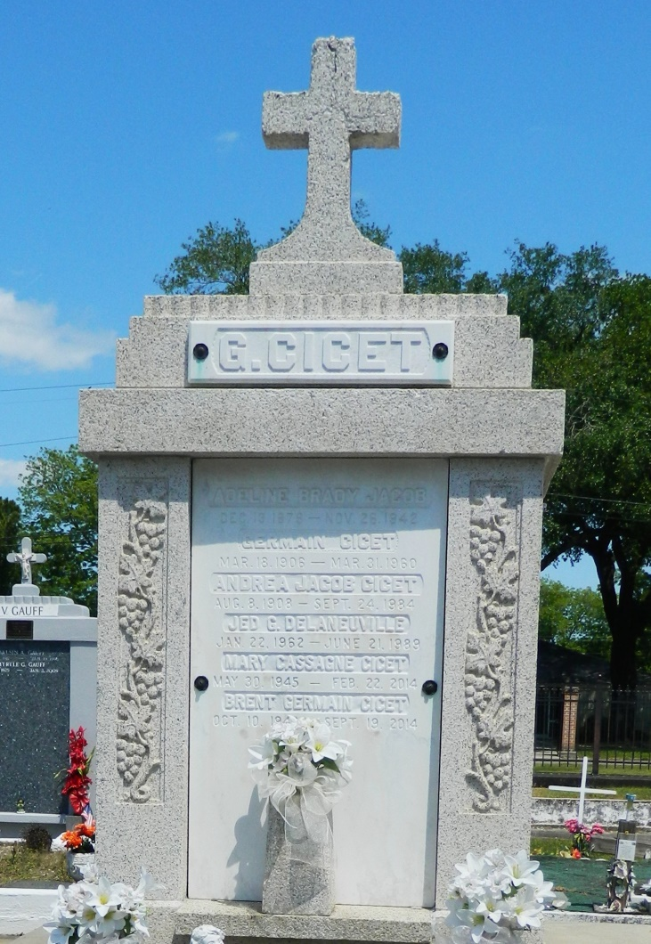

Brent G. Cicet, 71, died on Friday, Sept. 19, 2014.  
 He was the beloved husband of the late Mary Cassagne Cicet; father of Erica Maurin (Brett), Angela Cicet and Heather Giammanchere (Johnny); grandfather of Paige, Zachary and Lynsey Maurin and Carson Giammanchere; son of the late Germain and Andrea Jacob Cicet; brother of Laverne C. Delaneuville (Pelham); son-in-law of Jeanne Hymel Cassagne and the late Elmer Cassagne and brother-in-law of Ronald and Sharon Cassagne and Paula and Ray Roussel.  
 He retired from Dupont. He was a native and resident of Reserve.  
 Relatives and friends are invited to attend services. Visitation will take place at St. Peter Catholic Church in Reserve on Monday, Sept. 22, 2014, from 9 to 11 a.m., followed by Mass at 11 a.m. Burial will be in St. Peter Cemetery in Reserve.  
 Arrangements are being handled by Millet-Guidry Funeral Home in LaPlace.

L'Observateur (La Place, LA) - Monday, September 22, 2014

Contributed by Jane Edson