Mary (Cassagne) Cicet

May 30, 1945 – February 22, 2014

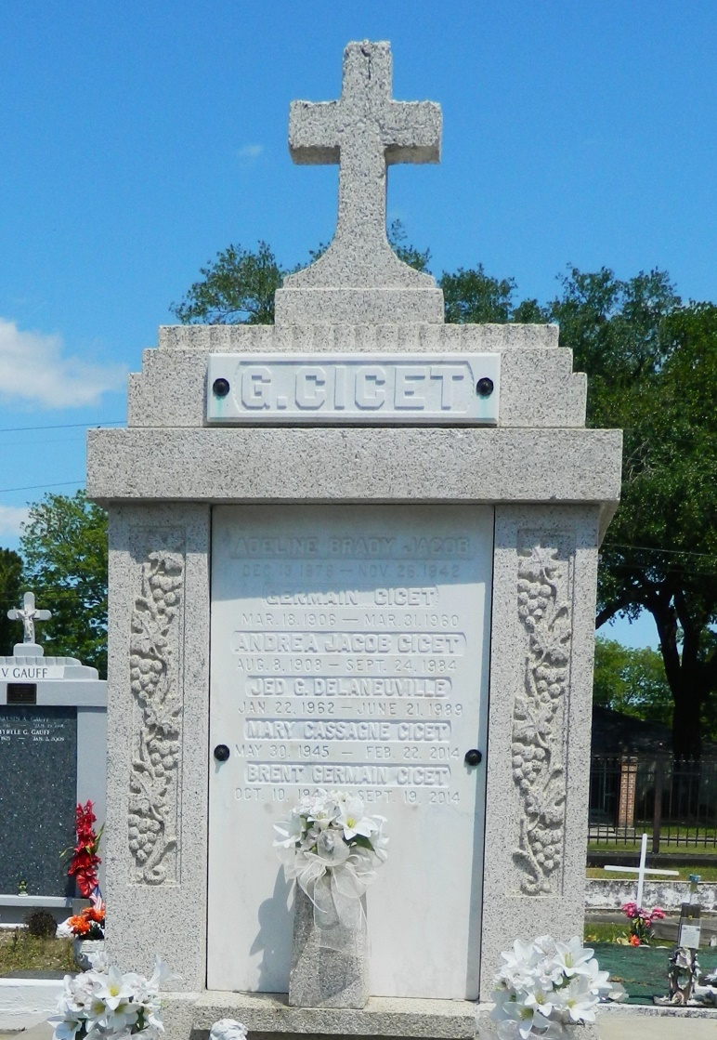

Mary Cassagne Cicet, 68, died on Saturday Feb. 22, 2014.  
 She was the beloved wife of Brent Cicet for 48 years, mother of Erica Maurin (Brett), Angela Cicet and Heather Giammanchere (Johnny). Grandmother of Paige, Zachary and Lynsey Maurin and Carson Giamman-chere, daughter of Jeanne Hymel Cassagne and the late Elmer Cassagne, sister of Ronald Cassagne (Sharon) and Paula Roussel (Ray) and sister-in-law of Laverne and Pelham Delaneuville.  
 She retired from Little Gypsy/Entergy after 19 years. She was a native and resident of Reserve.  
 Visitation and services were held at St. Peter Catholic Church in Reserve on Tuesday, Feb. 25, 2014. Burial followed in St. Peter Cemetery. In lieu of flower, the family prefers donations to St. Jude Children's Research Hospital. Arrangements were by Millet-Guidry Funeral Home of LaPlace.

L'Observateur (La Place, LA) - Tuesday, February 25, 2014

Contributed by Jane Edson