Valzume Cicet
February 11, 1868 – October 12, 1898

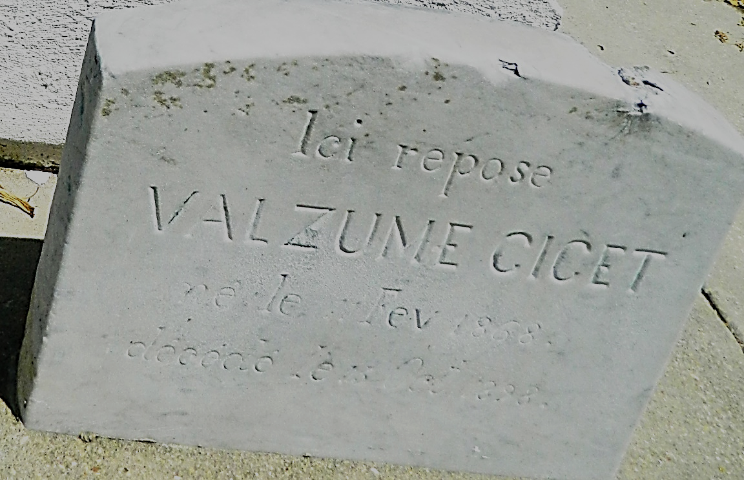

Valzume Cicet died on the left bank of the parish on Wednesday morning, 12 Oct 1898, at age about 30 years. He was a man whose life was all work and dedication to his family. His loss has caused deep sorrow to the entire community in the midst of which he was born and had always lived. He leaves a widow, Ameline Jacob, and three children.
See Death Notice, Le Meschacébé, 15 Oct 1898, page 4
**
He is listed in the index to St Peter Church Funerals, Register 2, p 260

Contributed by Dwayne Montz

