Blaine Anthony Clement
Abt. 1959 – August 8, 2017

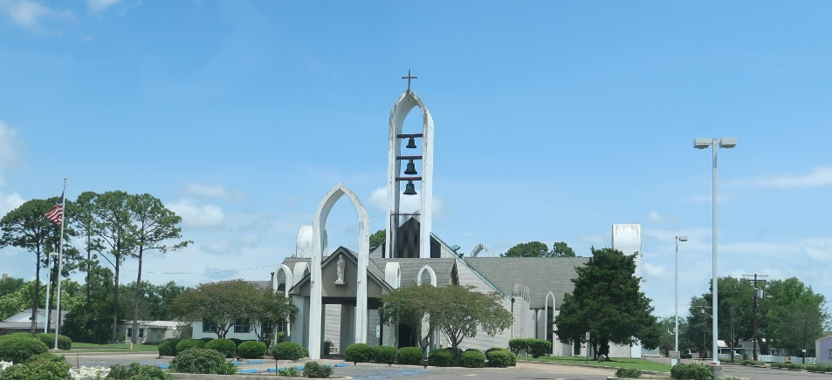

Blaine Anthony Clement, 58, native and resident of Reserve, LA entered eternal peace on Tuesday, August 8, 2017 at University Hospital, New Orleans, LA. Beloved father of Grace Ann (Carlos) Nicholas. He leaves to cherish his memories, siblings: Joey, Randy (Kathleen), Glenn (Tanya), Rusty (Jina) Clement, Shelly, (Parkash) Attul and Melissa Gill; Godmother Sandra Stein Cortez and Godfather, Wayne Matherne. He also leaves his grandchildren, whom he considered his pride and joy; Noah, Gabby, Brayden and Mason Nicholas. Missing him will also include former wife and long-time friend and mother of his only child, Lavona Clement Millet along with a host of aunts, uncles, nieces, nephews, cousins and friends. Blaine was a joy to many and found friendship with all he met. He was preceded in death by his parents, Emilien “Rinso” Jr. and Argie Clement and brother Harry Clement. He will be missed by all who loved and knew him. Employees of St. Charles Parish School Board, St. John Sheriff’s Office, Progressive Lodge 444-Metairie, and Shriners Hospital are invited at attend a Mass of Christian Burial on Saturday, August 12, 2017 at 12 noon from St. Peter Catholic Church, 1550 LA 44, Reserve, LA 70094. Father John Marse, Celebrant. Visitation begins at 10:00 am. Private burial to follow. In lieu of flowers, donations in honor of his memory are requested to be sent to Shriners Hospital for Children, 6977 Main Street, Houston, TX 77030.

Treasure of Life Center for Funeral Services, Gramercy, Louisiana
Contributed by Lavina Millet

