Clara (Duhe) Clement

February 3, 1864 – January 31, 1954

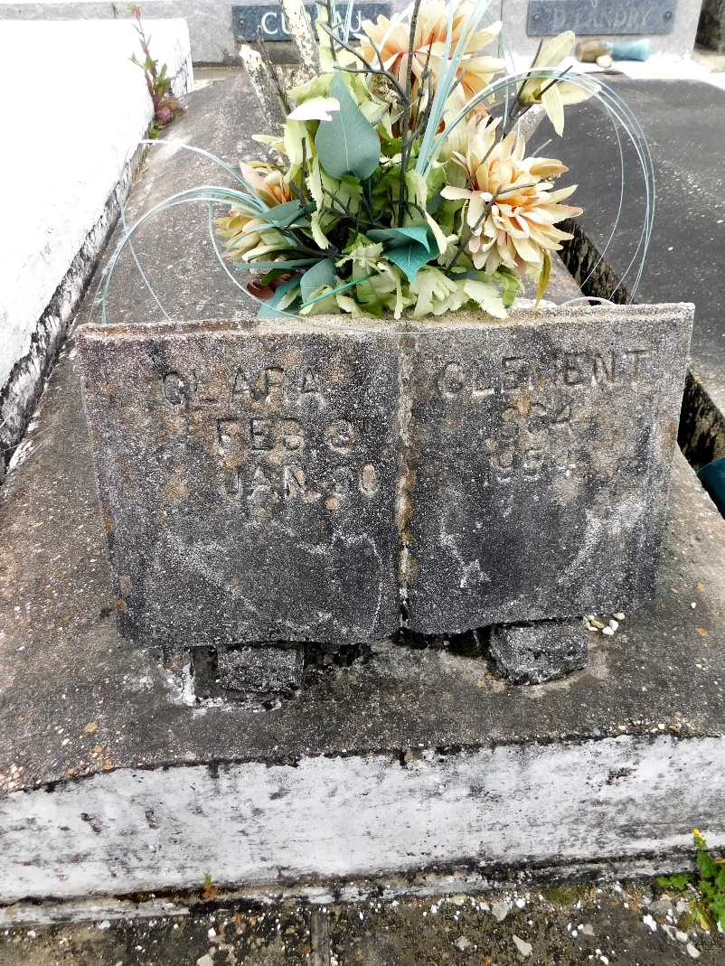

Photo by Mary Agnes Hammett

CLEMENT - On Sunday, January 31, 1954, at 3 o'clock a.m., CLARA DUHE, wife of the late Amedee Clement; mother of Mrs Willie Madere and Amedee and Edgar Clement of Laplace, La, Mrs Paul Vicknair of Montz, La, Mrs Alvin Guilliot of New Orleans, La, and Richard Clement of Destrehan, La; also survived by 30 grandchildren and 61 great grandchildren; aged 89 years. Relatives and friends of the family are invited to attend the funeral which will take place from the Millet funeral home, Laplace, La, on Monday, February 1, 1954, at 9 o'clock a.m., followed by mass at St Joan of Arc Church, Laplace, La. Interment in St Peter Cemetery, Reserve, La.

The Times-Picayune, New Orleans, Louisiana

1 Feb 1954, p 2