Debra Ann Clement
March 19, 1952 – November 13, 2006

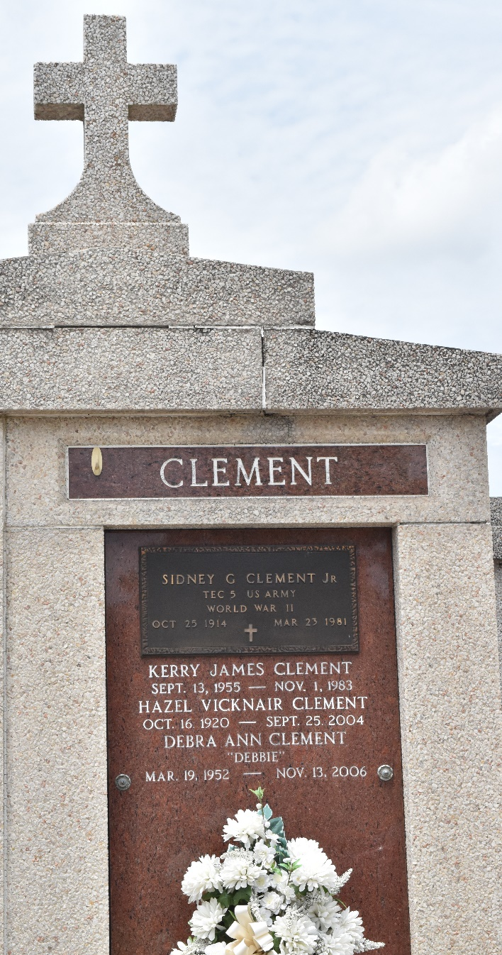

Debra (Debbie) Clement on Monday, November 13, 2006 at 11:45 a.m.
Beloved daughter of the late Sidney, Jr. and Hazel Vicknair Clement. Sister and sister-in-law of George and Virginia Clement of Hammond, Trixie and Wayne Poche of Paulina, Breland and Gayle Clement of Montz, Jennifer and Elton Remondet of Laplace, Judy Stromeyer of Ponchatoula, and the late Kerry Clement. Godmother of Dwayne Remondet, Alan Stromeyer and Brandi Remondet. Also survived by a number of nieces and nephews, great nieces and nephews, aunts, uncles, and her dog, Missy. Age 54. A native of Reserve and a resident of Laplace.
Relatives and friends of the family are invited to attend services. Visitation at Millet-Guidry Funeral Home, 2806 W. Airline Hwy, Laplace, on Wednesday, November 15, from 5 pm to 9 pm and on Thursday from 8 am to 10:30 am. followed by religious services at Ascension of Our Lord Catholic Church, Laplace at 11 a.m. Burial in St. Peter Cemetery, Reserve.

The Times-Picayune, New Orleans, Louisiana
Nov. 15, 2006

