Earl Louis Clement, Jr.
January 16, 1943 - October 20, 2019

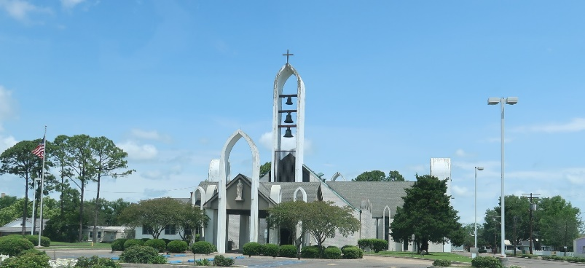

Earl Louis Clement, Jr., passed away peacefully at his home on Sunday, October 20th, 2019 surrounded by his family and loved ones. He was 76 years of age.
Born January 16th, 1943, Earl was a native of Reserve, LA and resided in Paulina, LA. He attended Leon Godchaux High School and graduated with the class of 1961. He then went to Delgado Community College and graduated with an Associate degree as a machinist. Earl enjoyed his early days of coaching football and little league baseball. He was a hard worker for over 44 years and retired from Shell Norco after 37 years of dedicated service. A Cowboy at his core, Earl had an unwavering love for his horses just as he did his family. He will be greatly missed by those that knew and loved him.
He is survived by his loving wife of 57 years, Darleen Duhe Clement; his sons, Earl Clement III (Danielle) and Chance Michael Clement (Ashley), his grandchildren, Kaleb Clement, Kullin Clement, Gabrielle Clement, Wyatt Clement, Charley Clement, Brian Hotard (Kayla), Madisyn Rodrigue; Earl is also survived by great-grandchild, Ava Hotard; siblings, Shirley Triche, Joan Guzzardo (John), Kenneth Clement (Joan), and nieces and nephews.
Earl was preceded in death by his two sons, Mark James Clement and Perry Lee Clement, his father, Earl Louis Clement and mother, Pearl Vicknair Clement; great-granddaughter, Aubree Hotard; niece, Christen Elizabeth Clement and brother-in-law, Ronald Triche.
Visitation will be on Thursday, October 24th, 2019 from 10:00 am to 1:00 pm at St. Peter Catholic Church in Reserve, LA. A Mass of Christian Burial will be at 1:00 pm on Thursday and burial will follow in the church cemetery.

Rose Lynn Funeral Home, Lutcher, Louisiana

