Ernest A. Clement, Sr.
May 3, 1931 – January 27, 2012

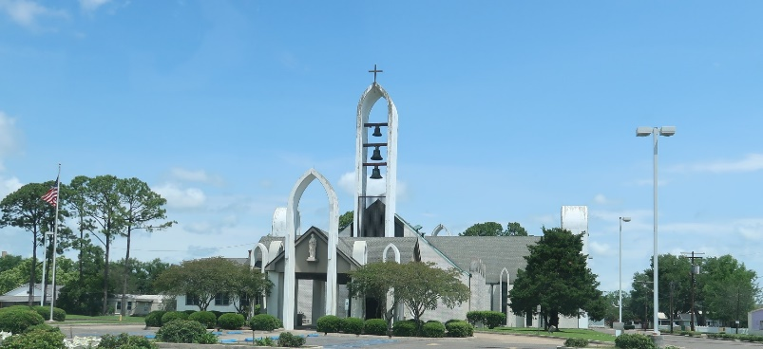

Ernest A. Clement, Sr., age 81, known to many as "Chin", died at River Parishes Hospital in LaPlace on Sunday, January 27, 2013.
He was born on May 3, 1931 to the late Paul and Noelie Clement. He was preceded in death by his wife, Joy Weber Clement, and his daughter, Jody Richardson. "Chin" is survived by his children: Cheryl Entremont (Greg), Penny Laiche (Lawrence, Jr.), Ernest "Ernie" Clement, Jr. (Karen), Darryl P. Clement (Noel), and Davey P. Clement (Dawn). He was the brother of J. P. Clement (Wanda), Barbara Simoneaux (Wayne), Juliet "Babe" Reine (Mack E.), and Farol Clement (Maddy). He had 11 grandchildren and 15 great grandchildren.
After graduating from Delgado Junior College, he was a long-time employee of Shell Oil Company in Norco and retired from Kaiser/LaRoche Chemical as an instrument mechanic. An avid outdoorsman, "Chin" loved to crayfish. Having played semi-professional baseball, he had a love of baseball his entire life, having taught many the skills of pitching. He was a huge LSU fan, and will be remembered by many for his service to St. John Parish serving as a Police Juror for 16 years, and for his countless hours spent taking care of his family and friends.
Visitation will be on Wednesday, January 30, 2013 from 6:00 p.m. until 9:00 p.m. at Rose Lynn Funeral Services, 1870 Cabanose Ave., Lutcher, LA. Visitation will resume at Rose Lynn Funeral Home on Thursday, January 31, 2013 from 8:00 a.m. until 9:30 a.m. followed by a Mass of Christian Burial at 10:00 a.m. at St. Peter Catholic Church in Reserve, LA. Interment will follow at a later date. ROSE LYNN FUNERAL SERVICES is in charge of arrangements.

The Advocate, Baton Rouge, Louisiana
Jan. 28 to Jan. 30, 2013

