Hazel (Vicknair) Clement
October 16, 1920 – September 25, 2004

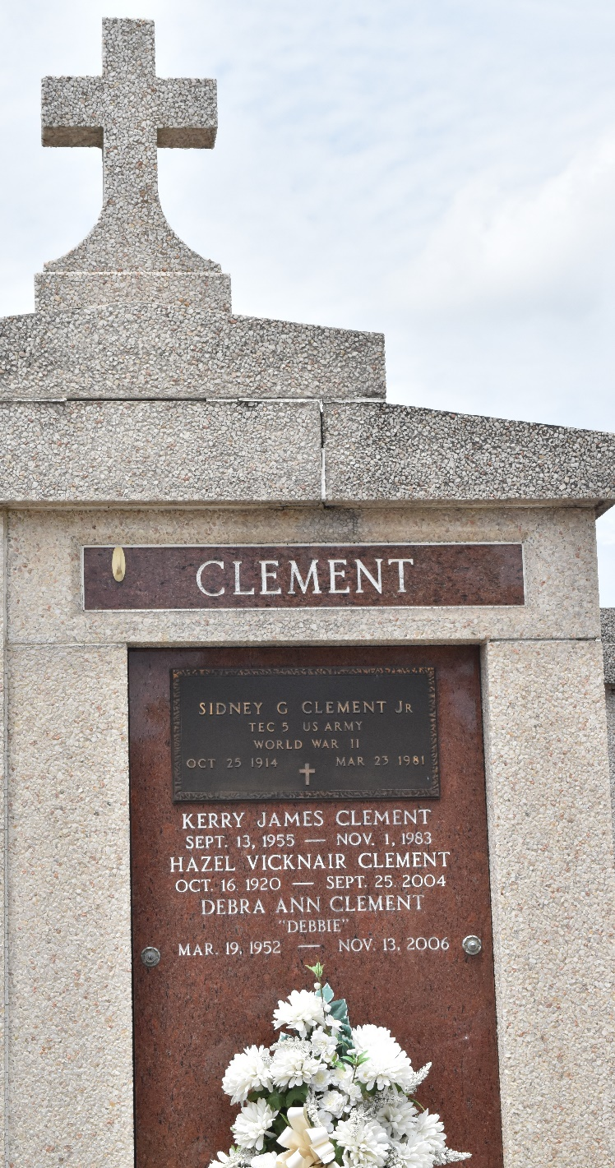

Hazel V. Clement on Saturday, September 25, 2004 at 7:40 P.M.
Beloved wife of the late Sidney Clement Jr. Mother and mother-in-law of George and Virginia Clement of Hammond, La, Trixie and Wayne Poche of Paulina, La, Breland and Gayle Clement of Montz, La, Jennifer and Elton Remondet of Laplace, La, Judy Stromeyer of Ponchatoula, La, Debra Clement of Laplace, La, and the late Kerry Clement. Daughter of the late Cyril and Beatrice Haydel Vicknair. Sister of Vivian Bergeron, Clifton, Merlin and Gerald Vicknair. Also survived by 16 grandchildren and 14 great grandchildren. Age 83 years. A native of Edgard and a resident of Laplace for the past 39 years.
Relatives and friends are invited to attend a Visitation at Millet Guidry Funeral Home, 2806 W Airline Hwy, Laplace, La, on Monday, September 27, 2004 from 5pm to 10pm and on Tuesday from 8am to 9:45 am. Followed by Religious Services at Ascension of Our Lord Catholic Church, Laplace at 10am. Burial in in St Peter Cemetery, Reserve, LA.
The Times-Picayune, New Orleans, Louisiana
September 27, 2004

