Joseph 'J.P.' Clement Jr.
December 6, 1929 - December 14, 2018

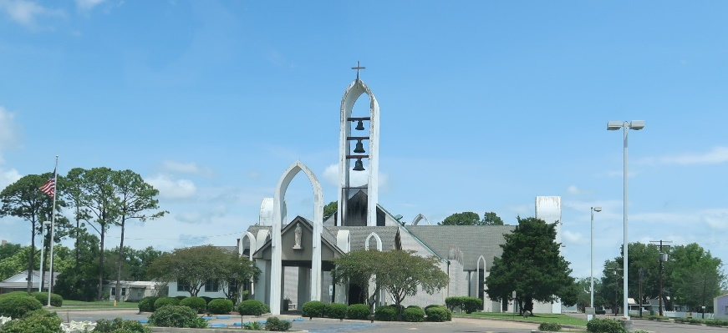

Joseph P. Clement, Jr. (J.P.) passed away peacefully on Friday, December 14, 2018 surrounded by his loving family.
He was 89, a native and resident of Reserve, LA. Beloved husband of Wanda Madere Clement of 68 years. Father of Keith Clement (Karen), Myra, Dedra Luminais (Tracy) and Laurie Alexander (Reed). Grandfather of Lee (Tina), Lane (Gina), Mandy, Megan, Rylee and the late Colby Boudreaux. Great-grandfather of Bree, Brennen and Makenzie. Son of the late Noelie Vicknair Clement and Paul Clement. Brother of Farol Clement, Juliet ‘Babe’ Reine and the late Ernest Clement ‘Chin’ and Barbara Simoneaux.
He was the most kind hearted person. His hobbies were raising beagles and rabbit hunting. Our father will be greatly missed.
Relatives and friends are invited to attend the Funeral Mass at St. Peter Catholic Church, 1550 Hwy 44, Reserve on Tuesday, December 18, 2018 at 11:00 a.m. Visitation will begin in church at 9:00 a.m. Interment in St. Peter Cemetery.

Millet-Guidry Funeral Home, LaPlace, Louisiana
December 17, 2018

