Kimberly (Savoie) Clement

October 17, 1979 – May 3, 2015

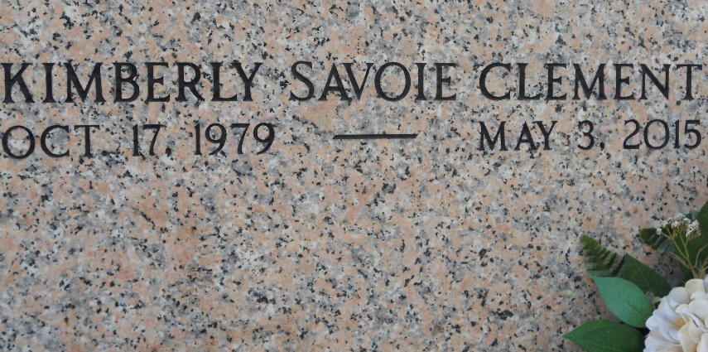

Kimberly Savoie Clement, 35, passed away on Sunday, May 3, 2015. She was a native of Reserve and a resident of LaPlace.

Clement is the beloved wife of Jeffrey Clement; mother of Anna Clement; and daughter of Doris Scioneaux Savoie and the late Lester Savoie. She is also survived by aunts, uncles, nieces, nephews, cousins and friends. She is also survived by aunts, uncles, nieces, nephews, cousins and friends.

Relatives and friends are invited to attend the visitation at Millet-Guidry Funeral Home, 2806 W. Airline Highway in LaPlace, on Thursday, May 7 from 5 until 8 p.m. Visitation is also on Friday at St. Joan of Arc Catholic Church, 529 W. 5th St. in LaPlace, from 11 a.m. until 1 p.m. Mass will be celebrated at 1 p.m. Interment is in St. Peter Cemetery.  To view or sign the online guest book, visit milletguidry.com.

L'Observateur, LaPlace, Louisiana

Tuesday, May 5, 2015

**

Kimberly Savoie Clement passed away on Sunday, May 3, 2015. She was 35, a native of Reserve, LA and a resident of LaPlace, LA. Beloved wife of Jeffrey Clement. Mother of Anna Clement. Daughter of Doris Scioneaux Savoie and the late Lester Savoie. Also survived by aunts, uncles, nieces, nephews, cousins and friends.

Relatives and friends are invited to attend the visitation at Millet-Guidry Funeral Home, 2806 W. Airline Hwy, LaPlace on Thursday, May 7, 2015 from 5:00 p.m. until 8:00 p.m. Visitation on Friday at St. Joan of Arc Catholic Church, 529 W. 5th St., LaPlace, from 11:00 a.m. until 1:00 p.m. Mass will be celebrated at 1:00 p.m. Interment in St. Peter Cemetery. To view or sign the online guest book, please visit [www.milletguidry.com](http://www.milletguidry.com/)

The Times-Picayune, New Orleans, Louisiana

May 5 to May 6, 2015