Maximilien Clement

March 13, 1868 – November 2, 1950

3/13/

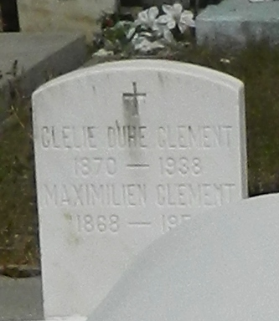

CLEMENT-On Thursday, 2 Nov 1950, at 4 o'clock p.m., MAXEMILIEN CLEMENT, husband of the late Clarie Duhe; father of Paul and Emilien Clement and Mrs. Felicien Vicknair; aged 84 years. Relatives and friends of the family are invited to attend the funeral which will take place from the Millet Funeral Home, Reserve, LA, on Friday 3 Nov 1950 at 4 o'clock p.m., followed by religious services at St Peter's Church, Reserve, LA. Interment in St Peter's Cemetery, Reserve, LA.

*Obituary, The Times-Picayune, New Orleans, LA; 3 Nov 1950, p. 2*