Simone (Vicknair) Clement

February 12, 1912 – October 5, 1973

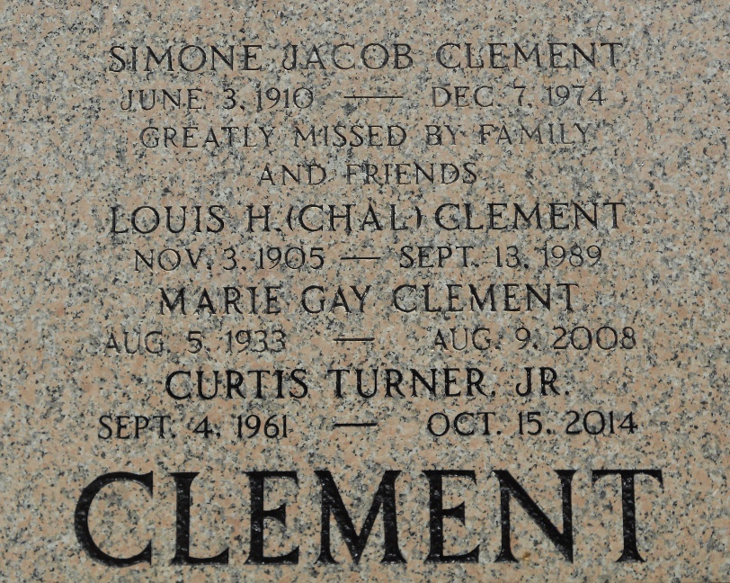

Wife of Lawrence Clement and mother of Mrs. Warren (Marian) Prudhomme, Lawrence Clement Jr, Lillie Mae, Harold, Dwight and Daniel Clement, all of Laplace, LA, Mrs. Kenneth (Faye Ann) Marse of Reserve, LA, and the late Lorraine Clement. She was the sister of Frank Jr and Joseph Vicknair, Mrs. Mabel Madere, Mrs. Lucy Guillory, Godfrey Vicknair and the late Odette Guillory. Age 61 years at her death, a native of Montz, LA, and resident of Laplace, LA.

The Times-Picayune, New Orleans, Louisiana

6 Oct 1973, p 16