Horace Clements

August 1, 1878 – December 14, 1957

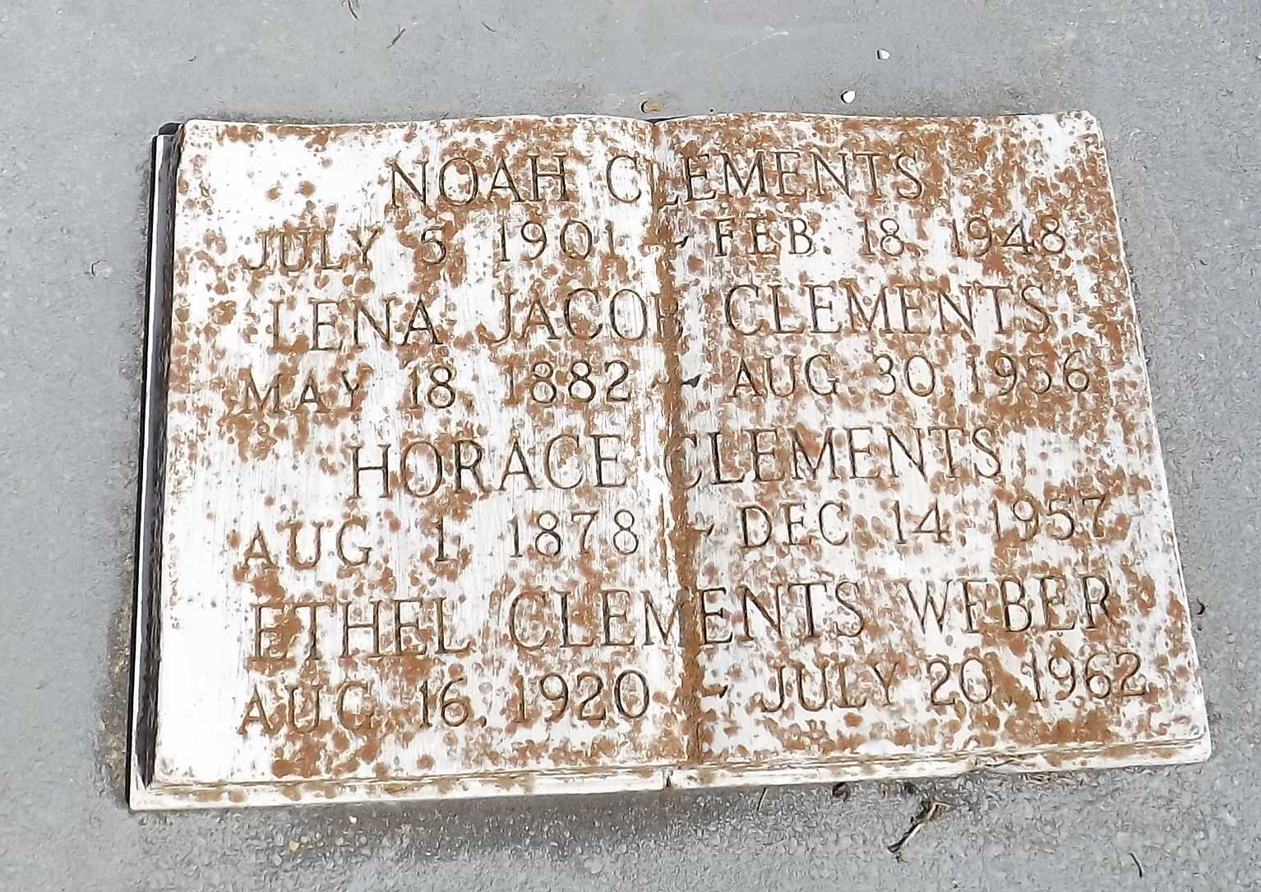

Photo by Mary Agnes Hammett

Horace Clements died on Saturday, 14 Dec 1957 at 12:35 p.m. at age 76 years.

He was the husband of the late Lena Jacobs and the father of Mrs. Clay Weber, Mrs. Clay Landry, Mrs. George Frost, Mrs. Constance Melancon, Mrs. Anthony Corona and the late Noah Clements. He was the brother of Miss Josephine Clements. Also survived by 32 grandchildren and 29 great-grandchildren. He was a native of Reserve, Louisiana, and a resident of New Orleans for the past two years.

Relatives and friends of the family are invited to attend the funeral which will take place from the Jules Millet Funeral Home, Reserve, on Monday 16 Dec 1857 with religious services at St Peter Church, Reserve. Interment in St Peter Cemetery, Reserve.

The Times-Picayune, New Orleans, Louisiana

December 15, 1957