Lena (Jacob) Clements

May 18, 1882 – January 30, 1956

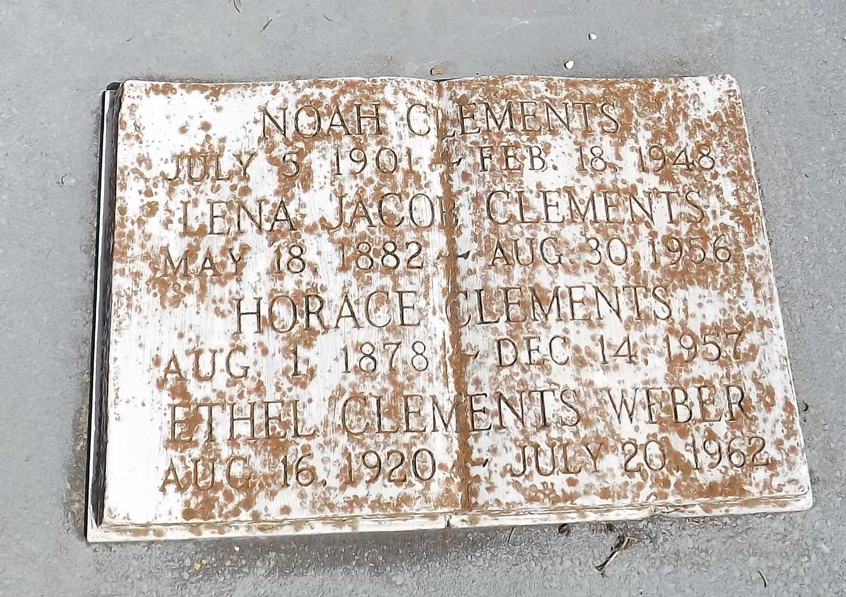

Photo by Mary Agnes Hammett

NOTE: Marker indicates death as 30 Aug 1956 however, her obituary is dated 1 Feb 1956 and lists her death as 30 Jan 1956.  
  
Lena Jacob Clements of New Sarpy, Louisiana, died on Monday 30 Jan 1956 at 4:30 p.m. at age 77 years. She was the wife of Horace Clements and the mother of Mrs. Clay Weber, Mrs. Clay Landry, Mrs. George Frost and Mrs. Constance Melancon of New Orleans, and Mrs. Anthony Caronna of New Sarpy, and the late Noah Clements. She was the sister of the late Clairville, Marcelius, Ozeme and Fremin Jacob. Also survived by 31 grandchildren and 20 great grandchildren. She was a native of Reserve, Louisiana, and a resident of New Sarpy for the past 34 years.

Relatives and friends of the family are invited to attend the funeral from Millet Funeral Home, Reserve, on Wednesday 1 Feb 1956 followed by religious services at St Peter Church, Reserve. Interment in St Peter Cemetery.

The Times-Picayune, New Orleans, Louisiana

February 1, 1956