Noah Clements

July 5, 1901 – February 18, 1948

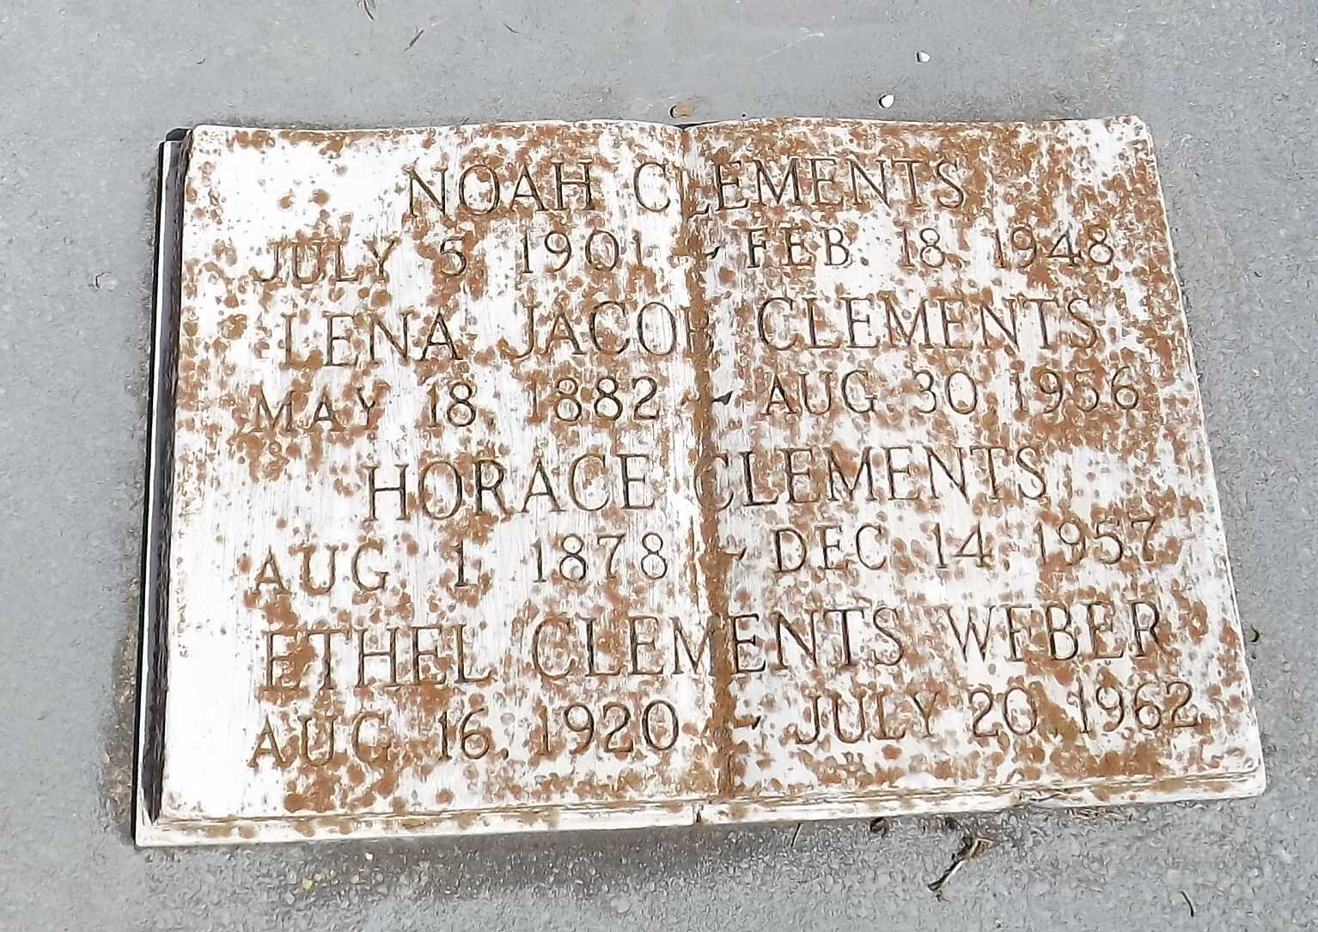

Photo by Mary Agnes Hammett

Noah Clement (sic) of 818 St Charles Street, New Orleans, died on Wednesday 18 Feb 1948 at 10 o'clock p.m. at age 48 years.

He was the husband of Louise Montaldo and the father of Mable, Marie and Pauline Clement and the late Mrs. Tony Petrolia. He was the son of Horace Clement and Lena Jacobs and the brother of Mrs. Clay F Weber, Mrs. Clay Landry, Mrs. Constance Melancon, Mrs. George Frost and Mrs. Garland Weber.

Relatives and friends of the family, also employees of Reiner's Jewelry Store, are invited to attend the funeral from Millet's Funeral Home, Reserve, Louisiana, on Friday 20 Feb 1948 followed by religious services at St Peter Church, Reserve. Interment in St Peter Cemetery, Reserve.

The Times-Picayune, New Orleans, Louisiana

February 20, 1948