Eleanor Ann (Toussel) Coberly

July 26, 1940 - February 14, 2018

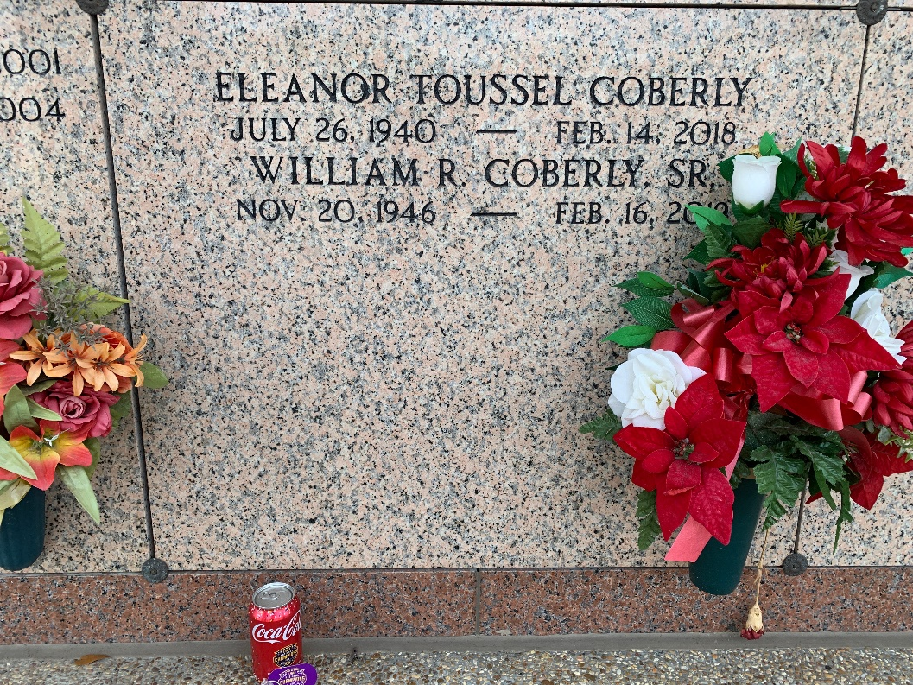

Photo by Team T-Lo

Eleanor Ann Roussel Coberly joined her Lord and Savior on February 14, 2018. A resident of Gonzales for the last 31 years, “Ellie” was a native of New Iberia and was a resident of St. John Parish for 42 years.  
 Ellie was the loving wife of William “Bill” Coberly for 31 years; the mother of Joseph G Roussel (deceased), Brent P Roussel II (Penny), Robert B Roussel (Joni), and Sean P Roussel (Mona), and the stepmother of Rodney Coberly, Shannon Coberly, and Nathan Coberly; grandmother of Brittany (Derrick) Roussel Gaubert, Blake (Stacy) Roussel, Nicholas Roussel, Aiden Roussel, and Benjamin Roussel; great-grandmother of Caroline, Ava, and Kate Gaubert and Austyn Roussel.  
She was preceded in death by her parents, Alfred B “Pemon” Toussel and Eunice Domingue Toussel. She is also survived by her sisters, Barbara Toussel King and Rachel Toussel Rasbery (James).  
 Eleanor graduated from Leon Godchaux High School in 1957 and Meadows Draughon Business College. In 1958 Eleanor was voted St. John Parish Sugar Queen and went on the represent St. John Parish in the state pageant. She was retired from Marathon Oil Company after a 20+ year career in Human Resources. Eleanor was a Cub Scout den mother, and a former member of the Krewe of Isis carnival organization.  
 The family would like to express their sincere thanks to Personal Homecare Services, especially Rebecca Rockstead, and St. Catherine’s Hospice, particularly Ashley Aucoin and Melissa Gros, for their exceptional care for our Mom.  
 A public visitation will be held at St. Peter Catholic Church, 1550 Hwy 44, Reserve from 9-11am on Saturday, February 17, with mass at 11:00 a.m. A Catholic burial will follow mass at St. Peter Cemetery, Reserve.  
 In lieu of flowers, Catholic masses are preferred. Arrangements by Millet-Guidry Funeral Home.

Millet-Guidry Funeral Home, LaPlace, Louisiana

February 16, 2018