Austin H. ‘Muggs’ Coleman

February 19, 1922 – February 3, 2009

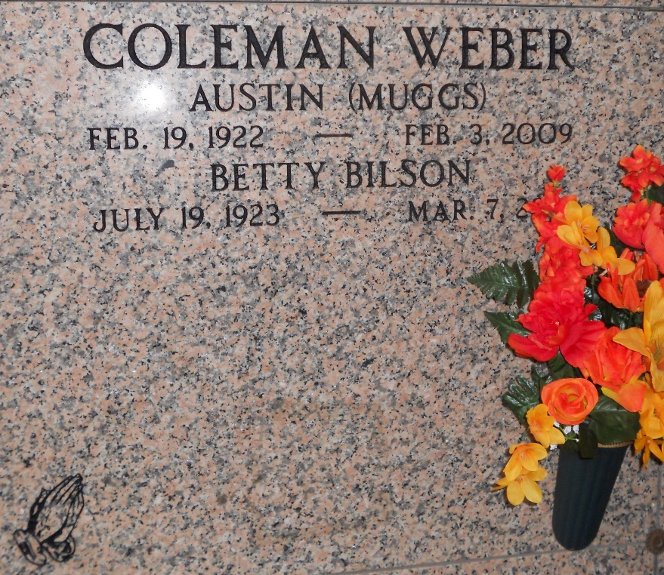

Photo by Team T-Lo

Austin was born on February 19, 1922 and passed away on Tuesday, February 3, 2009. Austin was a resident of La Place, Louisiana. Austin H. (Muggs) Coleman passed away at the Southeast Louisiana War Veteran's Home, Reserve, La. on Tuesday, February 3, 2009 at 3:04am.  
 Beloved husband of Betty Coleman for 62 years. Father of Claudia Weber and husband Wayne. Grandfather of Renee Millet and husband Todd and Robert Hebert and wife Teri. Proud great-grandfather of Nicole and T.J. Millet, Alyssa and Tori Hebert.  
 He was a veteran of the Army/Air Force and served during WW II. Muggs could be seen over the years along Airline Hwy. with his holiday yard art and painted pumpkins. Age 86 years. A native of Canada, former resident of Niagara Falls, New York and a resident of LaPlace for the past 29 years.  
 Relatives and friends are invited to attend services. Visitation at Lutheran Church of the Galilean, 3404 Hwy. 51, LaPlace, La., on Friday, February 6, 2009 from 12:00pm to 1:00pm. Followed by Religious Services at the church at 1:00pm. Burial to be private at a later date.  
 Donations preferred to the Southeast Louisiana War Veteran's Home, 4080 W. Airline Hwy., Reserve, La 70084. Arrangements by Millet-Guidry Funeral Home, LaPlace, La.  
  
Times Picayune, New Orleans, Louisiana

February 5, 2009