Parnell Michael Collins

January 14, 1963 – October 30, 2014

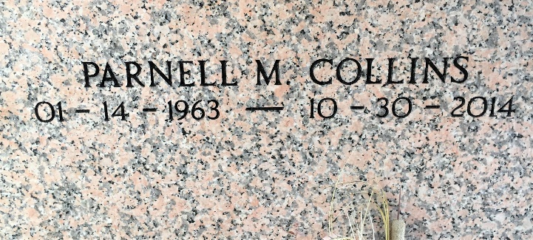

Photo by Team T-Lo

PARNELL MICHAEL COLLINS on Thursday, October 30, 2014 at Our Lady of the Lake Hospital, Baton Rouge, LA.

Son of Dolores "Cinderella" Jones Collins and Son Collins, Jr. Formally married to Anderia Marie Collins. Father of Nickyle Collins, Bonnie Carter, Ashley Collins, Brandy LaBranche, Tiera Collins, Angelica Collins and Kiana Collins. Brother of Cynthia Collins-Milton (Wayne), Crystal Jones, Kendric J. Collins, Robert Collins, Keith Noble and Candace Martin. Also survived by a devoted niece Kiera Janae Jones, 2 devoted nephews Kalen Collins and Khari Milton, 10 grandchildren, and a host of aunts, uncles, other nieces, other nephews, cousins, other relatives and friends. Age 51 years. A native of Reserve, LA and a resident of Baton Rouge, LA.

Relatives and friends of the family, also pastors, officers and members of Beechgrove Baptist Church and all neighboring churches are invited to attend the funeral service at Beechgrove Baptist Church, 117 Beech Grove Dr, Reserve, LA on Saturday, November 8, 2014 at 11:00 AM. Rev. Wesley Anderson, Sr., Pastor. Rev. Jeff Patterson, Officiating. Interment St. Peter Cemetery, Reserve, LA. Visitation at the above named church from 9:00 AM until service. SERVICED BY ROBOTTOM

The Times-Picayune, New Orleans, Louisiana

November 4-7, 2014