Son Collins, Jr.
February 1, 1937 - June 11th, 2019

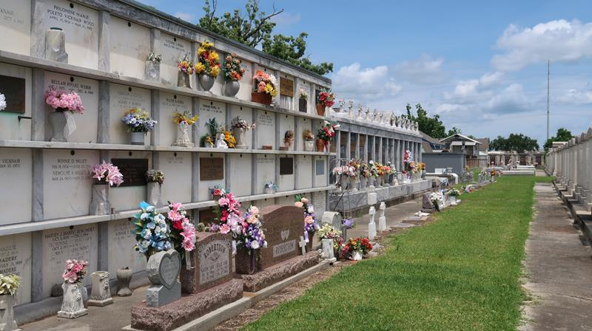

Son "Biddy" Collins, Jr., a native of LaPlace, LA entered into eternal rest on Tuesday, June 11, 2019 at the age of 82. He was the loving son of the late Son Collins, Sr. and Florence Smith Collins.
Son leaves to cherish his precious memories-devoted and loving wife, Cynthia Wiley Collins and her two children, who he reared, Tisha (Jeremy) Henry of LaPlace, LA and Marcus (Dernisha) Brown of Dallas, TX; The mother of his children, Delores Collins, daughter Cynthia (Wayne) Milton, Crystal Collins Jones of Reserve, LA and son Kendrick Collins of Atlanta, GA; daughter, Candace Martin and sons Robert Collins of LaPlace, LA and Keith (Cassandra) Nobles of New Orleans, LA. He will also be missed by brothers, Melvin (Nickel) Collins of Shrewsbury, MA, Glenn (Venessa) Collins of Reserve, LA; sisters, Mary Collins Brooks of St. Rose, LA, Gwendolyn (Leroy) Eaglin of Houston, TX, Rowena (Lonnie) Brown, Reserve, LA; sisters in law Betty Collins of Reserve, LA and Shelia Collins of New Orleans, LA. Son also leaves 26 grandchildren, two Godchildren, Timothy Williams and Emma Watkins, a host of great grandchildren and numerous nieces, nephews, cousins, and friends.
Relatives and friends of the family, also Pastors, Officers and Members of The Beech Grove Baptist Church, Mt. Zion #1 & #2 Baptist Church, Providence #2 Baptist Church, Mt. Nebo Baptist Church, New Wine Christian Fellowship, St. John Sheriff's Department, VA Medical Center of Reserve, LA; Louisiana Hospice and Palliative Care, Ochsner Medical Foundation of Kenner, LA and Family Home Care are invited to attend a funeral service on Saturday, June 22, 2019 from Beech Grove Baptist Church, 117 Beech Grove Drive, Reserve, LA. Viewing 8:00 am until service time at 10:00 am. Pastor Corey Batiste, officiant. Entombment St. Peter Catholic Church Cemetery, 143 W 7th St., Reserve, LA.

Treasures of Life Funeral Services, Gramercy, Louisiana

