George Edward Colopy
November 3, 1918 – January 1, 1990
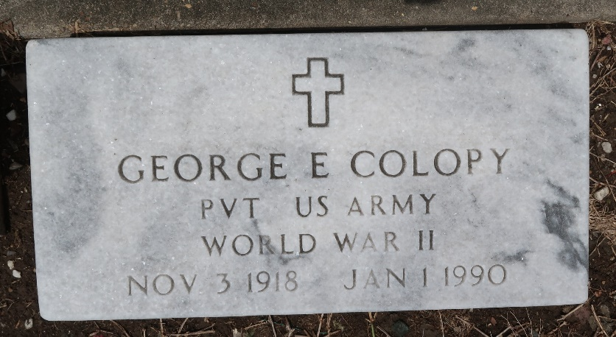

George E. Colopy, A Self-Employed Dry Wall Finisher, Died Monday At River Parish Hospital Of Cancer. He Was 71. Mr. Colopy Was Born In Danville, Kan., And Lived In Metairie For 27 Years.
Survivors Include Four Sons, Eric Joseph Colopy, Gerald Anthony Colopy And Charles Emile Colopy Of Georgia And Paul Perry Of California; Two Brothers, Charles Daniel Colopy And Joseph Eugene Colopy; Two Sisters, Mary Adelaide Domanoski And Laura Lucille Veline; And 10 Grandchildren.
A Mass Will Be Said Saturday At Tharp Sontheimer Tharp Funeral Home, 1600 N. Causeway Blvd. Burial Will Be In St. Peter Cemetery, Reserve.
Times Picayune, New Orleans, Louisiana
January 3, 1990

