Clifton James Conrad Sr.
August 6, 1939 – January 28, 2006

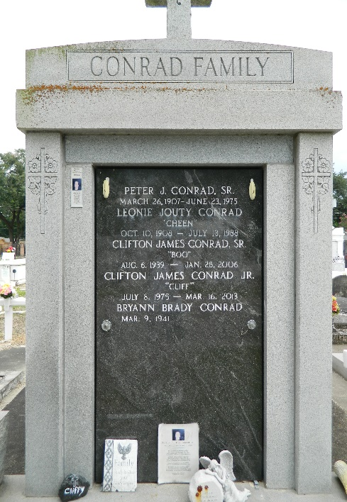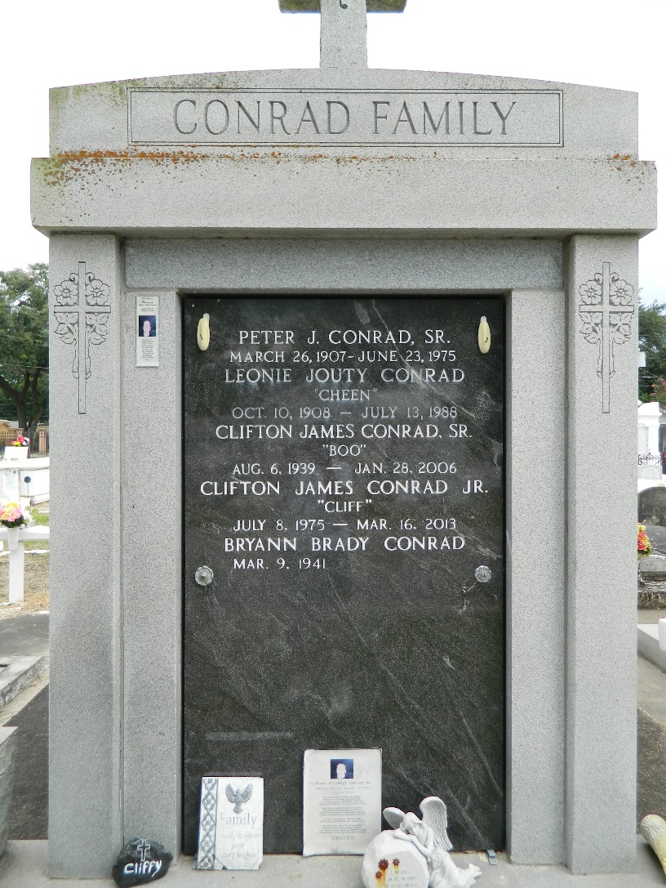

Clifton (Boo) Conrad, Sr. on Saturday, January 28, 2006 at 4:35 am. Beloved husband of Brynn Brady Conrad. Father of Clifton Conrad, Jr. Grandfather of Brook Conrad. Son of the late Peter Sr. and Leonie Jouty Conrad. Brother of Peter Conrad, Jr. Age 66 years. A native of and resident of Laplace, LA.
Relatives and friends of the family are invited to attend services. Visitation at Millet-Guidry Funeral Home, 2806 W. Airline Hwy., LaPlace, LA, on Tuesday, January 31, 2006 from 5 PM to 9 PM and Wednesday from 8 AM to 9:30 AM. Followed by Religious Services at St. Joan of Arc Catholic Church, LaPlace, LA at 10 am. Burial St. Peter Cemetery, Reserve, LA.
The Times-Picayune, New Orleans, Louisiana
Jan. 29, 2006

