Georgia Anne Theresa (Keller) Conway

November 12, 1962 – September 6, 2009

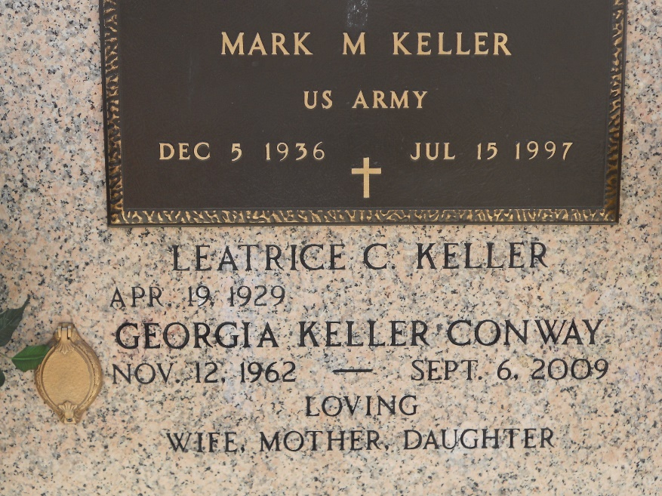

Photo by Team T-Lo

Georgia Keller Conway on Sunday, September 6, 2009 at 4:25 am.

Beloved wife of Dennis Conway. Mother of Lacy Burns. Step-mother of Ashley and Chestin Conway. Daughter of Leatrice (Cheesie) Keller and the late Mark Keller. Age 46. A native of Reserve, La. and a resident of Springfield, La.

Relatives and friends are invited to attend services. Visitation at Millet-Guidry Funeral Home, 2806 W. Airline Hwy. LaPlace, La. on Wednesday, September 9, 2009 from 5:00pm to 9:00 pm and on Thursday from 8:00 am to 9:45 am. Followed by a Mass at St. Peter Catholic Church, Reserve, La. at 10:00 am. Burial in St. Peter Cemetery.

Times Picayune, New Orleans, Louisiana

September 9, 2009