Ida Mary (Lewis) Cook
1929 – June 18, 2003

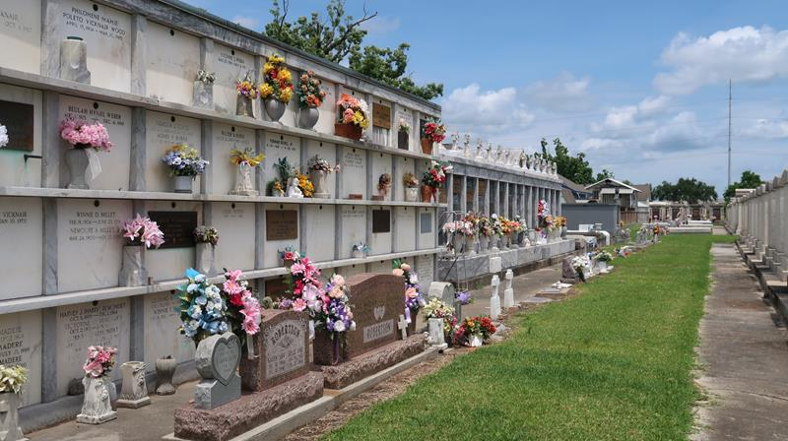

Ida M. (Royalty) Cook Fell Asleep In Christ At Canon Hospice, Jefferson, La On Wednesday, June 18, 2003. Age 74 Years. A Native Of Laplace, La, Lived In Milwaukee, WI For 38 Years And Retired To Metairie, La In 1999.
Daughter Of The Late Ida Alexis And Antoine Lewis, Sr. Wife Of The Late Glenzy Cook By Second Marriage And George W. Royalty, Jr. By First Marriage. Mother Of Sulaiman (Marvin) Badia, Marlene M. Royalty, Denise F. Royalty And Robin (Lewis) Hellen. Sister Of Clifford (Katchie) Lewis, The Late Cleveland (Bay) Lewis, Antoine (Jack) Lewis, Jr., Lionel (Papa Noodie) Lewis, Lawrence (Boy) Lewis, Sr., Ernest Lewis, Edwin (Blue) Lewis And Alberta Anderson. Grandmother Of Adrian T. Royalty Of Milwaukee, Wi, Renise N. Young Of New Orleans, La And Qiyas D. Smith Of Metairie, La. Preceded In Death By Her Godmother Ruth B. Nobles. Also Survived By 10 Sisters-In-Law, 5 Brothers-In-Law, 5 Great- Grandchildren And A Host Of Nieces, Nephews, Other Relatives And Friends
Relatives And Friends Of The Family, Also Priest And Parishioners Of Our Lady Catholic Church, St. Monica Catholic Church Of New Orleans, La And All Neighboring Churches, Members Of The Knights Of Peter Claver Ladies Of Auxillary St. Catherine Drexel Court #59, And Knights Of Peter Claver Evelyn Ashe Ladies Of Grace 4th Degree Division Chapter 31 Of Milwaukee, Wi Are Invited To Attend The Mass Of Christian Burial At Our Lady Of Grace Catholic Church, 744 Highway 44, (River Road), Reserve, La On Saturday, June 28, 2003 At 11:00 Am. Father Asare-Dankwah, Celebrant, Father Joseph Rodney, Co-Celebrant. Interment St. Peter Cemetery, Reserve, La. Visitation At Our Lady Of Grace Catholic Church From 9:00 Am Until Mass Time. Recitation Of The Rosary At 10:15 Am. Serviced By Robottom.

Times Picayune, New Orleans, Louisiana
June 27, 2003

