Larry Joseph Cook Sr.

October 2, 1931 – January 4, 2020

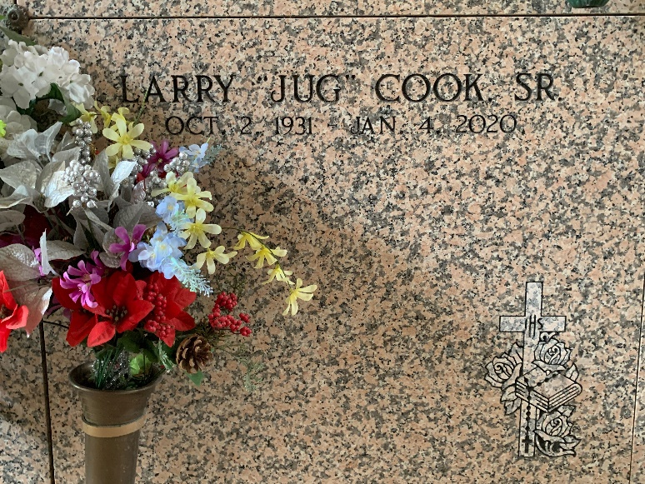

Photo by Team T-Lo

Larry Joseph Cook, Sr. at the age of 88 years old departed this earthly life and entered eternal rest on January 4, 2020, at Ochsner Baptist Hospital surrounded by his loving family.

Larry was the son of the late Hampton and Stella Placide Cook and the husband of the late Theresa Desselle Cook. Loving father of Larry Cook, Jr., Janice Cook, Julie C. Variste (Clarence), Karen Cook, Kevin Cook (Beatrice), Durel Cook (Judy), Darryl Cook, Connie C. Ramos (Nelson, Sr.), and the late Ronald Cook. Brother of Ollie Mae Anderson and David Cook, Sr. Also, survived by 13 grandchildren, 7 great-grandchildren, and a host of nieces, nephews, relatives, and friends.

Larry was preceded in death by his parents, Hampton and Stella Placide Cook; wife, Theresa Desselle Cook; and sisters, Audrey Cook Gregoire and Stella Jean Cook Edwards. A native and resident of Reserve, LA.

Priest and parishioners of Our Lady of Grace Catholic Church, St. John the Baptist Sheriff's Office, Walmart, Humana, and all neighboring churches are invited to attend the homegoing celebration on Saturday, January 11, 2020 at 10 a.m. at Our Lady of Grace Catholic Church, Reserve, LA. Father Christopher Amadi, SSJ officiating. Interment, St. Peter's Cemetery, Reserve, LA. Visitation at the above the name church from 8:15 a.m. until service time. Bardell's Mortuary in charge. Information: (985) 535-6837.

The Times-Picayune, New Orleans, Louisiana

Jan. 10, 2020