Lawrence Lee Cook

May 6, 1936 – October 4, 2000

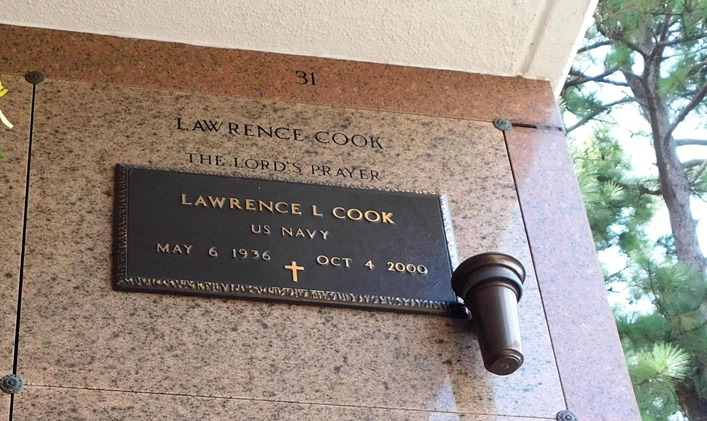

Photo by Mary Agnes Hammett

Lawrence Lee Cook, a retired merchant marine, died Wednesday of a heart attack at the Veterans Affairs Hospital in New Orleans. He was 64.

Mr. Cook was a lifelong resident of Reserve. He served in the Navy. Survivors include three sons, Manuel Cook, Alonza Webb and Adrea Webb; a daughter, Erica Cook of Reserve; a stepdaughter, Lynn Hartford; five brothers, Arthur Cook of Slidell, Alvin Cook of LaPlace, Oscar Jr., Henry and Elmo Cook, all of Reserve; three sisters, Marie Cook, Veronica Bailey and Goldie Wilkens; and a grandchild.

A Mass will be said Tuesday at 11 a.m. at Our Lady of Grace Catholic Church in Reserve. Burial will be in St. Peter's Cemetery in Reserve. Robottom Mortuary is in charge of arrangements.

The Times-Picayune, New Orleans, Louisiana

Monday, October 9, 2000