Nellie (Clement) Coquyt

May 12, 1896 – December 23, 1980

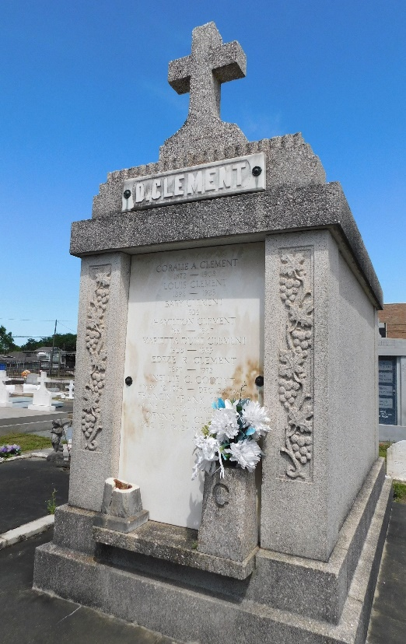 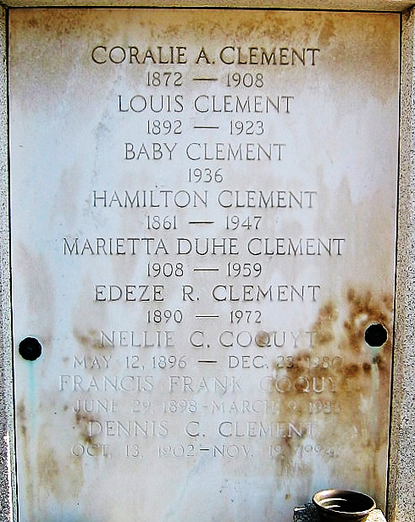

Photo by Mary Agnes Hammett Photo by Bobby

Notes the death of Nellie C Coquyt Tuesday 23 Dec 1980 at age 84 years. Wife of Frank Coquyt and mother of Francis J and Norman J Coquyt, and Martha St Germain. Sister of Emile M Clement, Dennis J Clement Sr, Lucille Robeau and Claire Rheinheimer.

Nellie was a native and resident of Laplace, LA. Interment was in St Peter Cemetery, Reserve, LA.

The Times-Picayune, New Orleans, Louisiana

24 Dec 1980, page 15