Wallace ‘Stump’ Cortez

February 19, 1912 – August 23, 2002

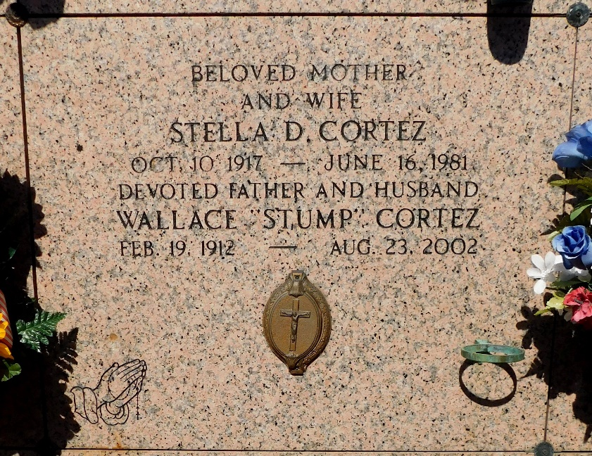

Photo by Mary Agnes Hammett

Wallace (Stump) Cortez On Friday, 08-23-2002 At 7:55 am.

Beloved Husband Of The Late Stella Demarco Cortez. Father And Father-In-Law Of June & J. P. (Mule) Pollet, Jeanette (Country) & The Late Donald Larousse, Joan (City) & Peter Roppolo, Katherine & Roland Sapia, Judy & Ronnie St. Pierre, Sandra Boe, Stephanie & Patrick Bourgeois. Son Of The Late Joseph And Bertha Mury Cortez. Bro. Of Norward Paul Cortez, And The Late Victor, Anna, Emile, Lovinia, Alice, Alicia, Althea, Anastasia & Joseph Cortez. Also Survived By 20 Grandchildren, One Deceased And 25 Great Grandchilden. Age 90 Years, A Native Of Convent And A Resident Of Reserve For The Past 70 Years.

Relatives And Friends Of The Family Are Invited To Attend Services. Visitation At St. Peter Catholic Church, Reserve, La. On Monday, 08-26-2002 From 9am To 12pm. Followed By Religious Services At St. Peter Catholic Church, Reserve At 12pm. Burial In St. Peter Cemetery, Reserve, La. Arrangements By Millet-Guidry Funeral Home, Laplace, La.

Times-Picayune, New Orleans, Louisiana

August 25, 2002