Sharon (Pellissier) Cotham

September 18, 1951 - September 20, 2014

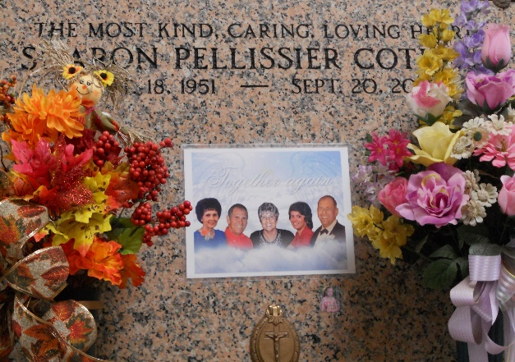

Photo by Team T-Lo

Sharon Pellissier Cotham, 63, the most kind, caring and loving heart, was reborn to the waiting arms of her family on September 20, 2014. Born on September 18, 1951 and last surviving member of her family, she will be greeted at the pearly gates by her father Curtis Pellissier, mother Louise Pellissier, brother Marlon Pellissier and sister Gaynel P. Roussel. She was a native of Garyville and a resident of Gramercy.

She spent her days as a devoted wife, stay at home mom and then loving grandmother, where she cut grass, kept a spotless house, taught baton twirling, was the president of the PTA, coached her daughter's cabbage ball team, did crafts that she gave away as gifts or used to decorate her home for the holidays, taught line dancing, cooked and brought meals to anyone in the neighborhood in need; babysat her grandchildren even having them overnight, and made trips to her home away from home in Grand Isle.

She is survived by her loving high school sweetheart turned husband on September 20, 1969 Michael Cotham, daughter Deana Cotham-Judy (husband Ronald Judy), son Curtis Cotham (wife Darryllynn Cotham) and Denise. She is also survived by her grandchildren: April St. Pierre, Preston St. Pierre, Emily Ryland., and Curtis Marlon Cotham; step grandchildren: Kristen Ryland., Ashlie, Matthew and Joseph Cockburn. She is also survived by two step great-grandchildren, numerous nieces and nephews and a host of other relatives and friends.

Visitation will be held at Rose Lynn Funeral Home, 1870 Cabanose Ave., Lutcher, LA on Wednesday, September 24, 2014 starting at 6:00 pm until 9:00 pm. Funeral services will also be held at Rose Lynn Funeral Home on Thursday, September 25, 2014 starting at 9:00 am, followed by a Mass at 10:30 am with burial immediately after at St. Peter's Cemetery in Reserve, LA. Pallbearers for her service will be John St. Pierre, Preston St. Pierre, Curtis Cotham, Ronald Judy, Danny Roussel and Dallas Roussel.

The family would like to express their heartfelt thanks to the caregivers at Hospice Compassus for all their love, devotion and compassion over the last thirteen months. ROSE LYNN FUNERAL SERVICES is in charge of the arrangements.

The New Orleans Advocate, Louisiana

Sep. 22 to Sep. 23, 2014