Roland John Courville
April 30, 1938 - March 16, 2019

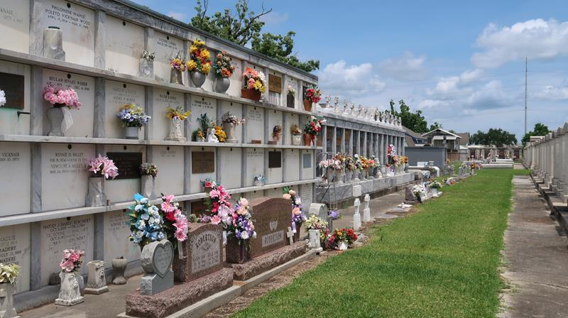

Roland John Courville passed away at his residence on Saturday, March 16, 2019 at the age of 80. He was born in Breaux Bridge, LA and was a resident of Montz.
Beloved husband of the late Shirley B. Courville. Loving father of Louis J. Courville and Sable C. Bell. Grandfather of 9 grandchildren and 23 great grandchildren. He was also preceded in death by his sons, John R. Courville, Jr.(Judy) and Clay J. Courville (Connie); his parents, Clay Courville and Leota Latoilais Courville; and his brothers and sisters. He is also survived by many nieces and nephews.
Relatives and friends are invited to attend the Memorial Mass at Millet-Guidry Funeral Home, 2806 W. Airline Hwy., LaPlace on Saturday, March 23, 2019 at 1:00 p.m. Visitation will be held from 11:00 a.m to 1:00 p.m. Interment will be held at a later date in St. Peter Cemetery. In lieu of flowers, masses preferred.

Millet-Guidry Funeral Home, LaPlace, Louisiana
March 19, 2019

