Shirley (Belaire) Courville

September 17, 1939 – February 28, 2001

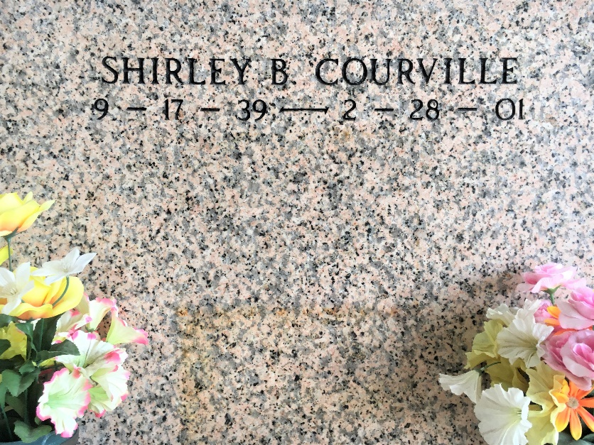

Photo by Team T-Lo

LAPLACE - Shirley Belaire Courville, 61, a native of St. Martinville and resident of LaPlace for 20 years, died Feb. 28.

She was the wife of Roland Courville and mother of Sable Bell, Louis, John and Clay Courville. She was also the daughter of the late Louis and Olive Belaire and sister of Mary Alice Champagne, Olive Latiolais and the late Ames Belaire. She is also survived by nine grandchildren and six great-grandchildren.

Services were March 2 in the chapel of Millet-Guidry Funeral Home, LaPlace, with interment at St. Peter Cemetery, Reserve.

L'Observateur, LaPlace, Louisiana

March 3, 2001