Anna Lee (Michel) Cox

January 10, 1933 – February 1, 2022

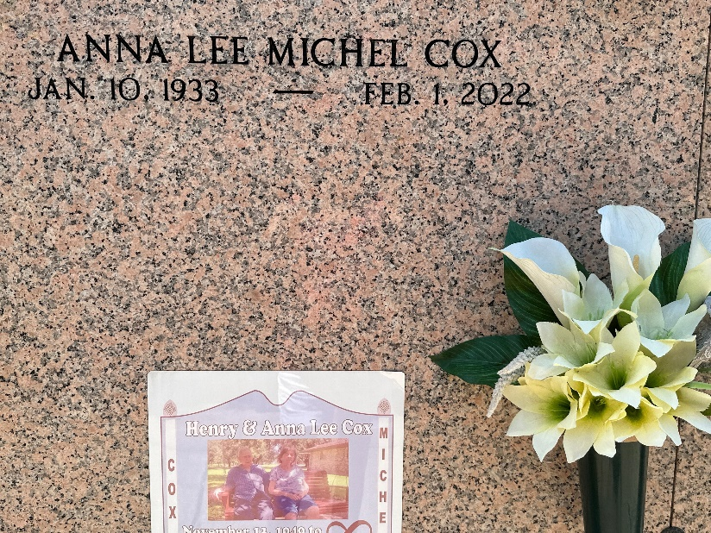

Photo by Team T-Lo

Anna Lee Michel Cox was born on January 10, 1933 and passed away peacefully at her residence, at the age of 89 years old. She was a native of Convent, LA and a resident of Reserve, LA.

Anna Lee is survived by her children; Henry Joseph Cox Jr. (Geraldine Gendron), Robert Dale Cox (Lydia Townsend), Gary James Cox Sr. (Lynette Monica Landry), Kevin Paul Cox (Susan Landry), and Jeffrey Paul Cox (Stephanie Maurin); grandchildren, Gary Cox Jr.,(Kim) Michelle Cox Brossette (James), Sherrie Cox Weiser (Jason), Stephanie Cox Granier (Jeremy), Henry Cox III, (Julie), Jenny Cox Cuevas (Daniel), Matthew Cox (Tara), Diane Cox Cueller (Jose), Jeremy Cox (Brandi), and Samuel Cox; great grandchildren, Devan Cox (Haley), Chloe and Allie Revere, Makenzie Granier, Elena & Elijah Cueller, Henry IV & Harper Cox, Katherine & Abigail Cox, Shane, Abby, Katie, and Lance Weiser, Jude, Jonah, and Cora Cuevas; great-great granddaughter, Isabella Cox; sisters, Rowena M. Duhe, Irma M. Matherne and Mary M. Audiffred as well as a host of nieces and nephews.

She is preceded in death by her loving husband Henry J. Cox Sr., Parents; Anthony & Norbertile Michel, sisters; Irene Michel Milioto, Eva Mae Michel Troxler; brothers, Alvin Pete Michel, Edwin Tboy Michel, Leroy Michel, Anthony Michel Jr., and Johnny Michel; daughter in law, Kim Wempren Cox; grandson, William Cox, and great granddaughter Devaney Cox.

She was a simple woman, a devoted wife and mother of five boys. She loved her children and grandchildren with all her heart. She enjoyed cooking, sewing, making puzzles and listening to old country music. She was the matriarch of her family and will be greatly missed.

A visitation will be held at St Peter's Catholic Church on Tuesday, February 8, 2022 from 9:00 am until funeral time. A Mass of Christian Burial will take place at 11:00 am. Interment will follow in the church cemetery.

Rose Lynn Funeral Home, Lutcher, Louisiana

February 25, 2022