Henry Joseph Cox Sr.

September 1, 1927 – August 28, 2021

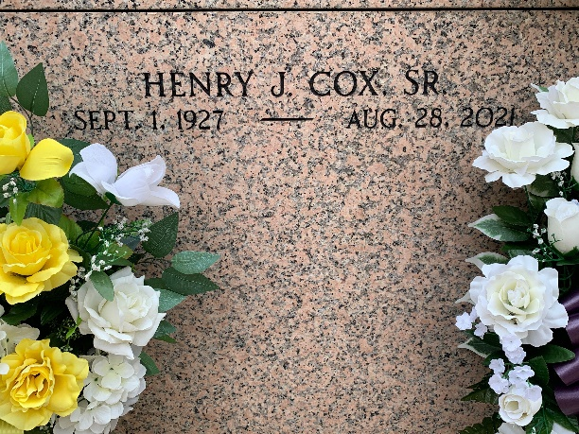

Photo by Team T-Lo

Henry Joseph Cox, Sr. was born on September 1, 1927 and passed away peacefully at his home on August 28, 2021 at the age of 93 years old. He was a native and resident of Reserve, LA.  
 Henry is survived by his wife of 70 years, Anna Lee Michel; children, Henry Joseph Cox, Jr (Geraldine Gendron), Robert Dale Cox (Lydia Townsend), Gary James Cox, Sr. (Lynette Monica Landry), Kevin Paul Cox (Susan Landry), Jeffery Paul Cox (Stephanie Maurin); grandchildren, Gary Cox Jr. (Kim), Michelle Brossette (James), Sherrie Weiser (Jason), Stephanie Granier (Jeremy), Henry Joseph Cox III (Julie), Jenny Cuevas (Daniel), Matthew Cox (Tara), Diane Cuellar (Jose), Jeremy Cox (Brandi), Samuel Cox; great-grandchildren, Devin Cox (Haley), Chloe and Allie Revere, Makenzie Granier, Elena and Elijah Cuellar, Henry IV and Harper Cox, Katherine and Abigail Cox, Shane Weiser, Abby, Katie, and Lance Weiser, Jude, Jonah, and Cora Cuevas, and Dominic Foret; great great-granddaughter, Isabella Cox; as well as a host of nieces and nephews.  
 He is preceded in death by his parents, John and Ezilda Cox; sister Katherine Cox Louque; brothers, Vernon Cox, CJ Cox, and Donald Cox; daughter-in-law, Kim Wempren Cox; grandson, William Cox; and great-granddaughter, Devaney Cox.  
 He was known as a hard worker and a simple man who loved his children and grandchildren. He loved planting trees and cooking for his family. His fudge was known as the best! He always had a smile on his face and loved to share the past with anyone who would listen. He was a true patriarch of his family and shared his knowledge well into his 90's. Henry loved to play cards and one of his favorite games was Rummy and getting the Jokers.  
 A visitation will be held at Rose Lynn Funeral Home in Lutcher, LA on Thursday, September 10, 2021 from 8:00 AM to 10:00 AM. A Catholic prayer service will follow at 10:00 AM. Interment will take place in St. Peter Cemetery.  
 Rose Lynn Funeral Home is in charge of the arrangements.

The Times-Picayune, New Orleans, Louisiana

Sep. 7 to Sep. 9, 2021