Donna (Melancon) Crotty-Terrio
August 25, 1950 - April 8, 2024

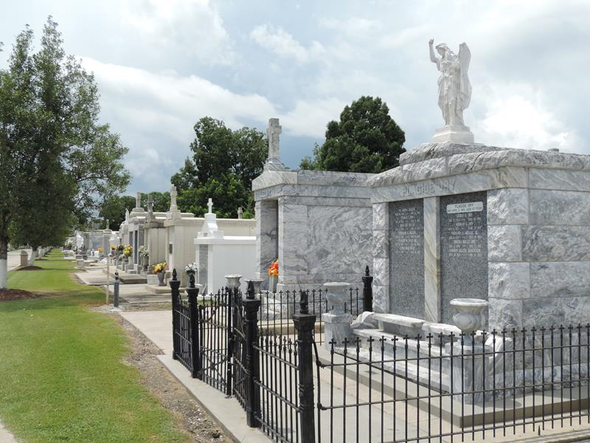

Donna Melancon Crotty Terrio passed away on Monday, April 8, 2024 at the age of 73 with her family by her side. She was born in Lutcher, LA and a life-long resident of Garyville, LA.
Beloved wife of Danny Terrio for 36 years. Loving mother to her 3 children Nathan Crotty, Bethany Crotty Kincheloe (Justin), and Donny Terrio (Lauren). Cherished grandmother of the late Duane Cecil Crotty II, Deryk Kincheloe (Elizabeth), Abigail Kincheloe, Reese Terrio, and Miles Terrio. Sister of Wendell “Nemo” Melancon, Terrell Melancon and Timmy Melancon (Debbie). Also survived by numerous nieces, nephews, and cousins.
She was preceded in death by her parents Eunice and Gerald Melancon and her first husband, Duane Cecil Crotty.
To know Donna is to know the true meaning of selflessness. She was a kind-hearted, thoughtful, and devout Catholic who admired and lived by the way of St. Therese of Lisieux, “The Little Flower”. There was no craft or hobby that Donna did not excel at. Whether it was painting with her friends or grandchildren, sewing and gardening at home, decorating for holidays and events, baking and cooking delicious meals, and making her homemade blackberry jelly. She enjoyed collecting depression glass and was a member and president of the Crescent City Depression Glass Society. She looked forward to her many outings with The Ladies of ’68, dancing and listening to swamp pop, and having get-togethers with cousins and life-long friends. Through her courageous battle with breast cancer, she captured the hearts of her trusted physicians, nurses, and caregivers.
Donna was the heart of her family and will be forever missed.
Relatives and friends are invited to attend the Visitation and Funeral Mass at St. Hubert Catholic Church,176 Anthony F Monica St., Garyville, LA on Monday, April 15, 2024. Visitation at the church from 9:00 a.m. to 11:00 a.m. followed by a Funeral Mass at 11:00 a.m. Interment in St. Peter Cemetery, Reserve, LA.

Rose Lynn Funeral Home, Lutcher, Louisiana
April 10, 2024

