Dorothy Ann ‘Dolly’ (Catoire) Crowell

September 25, 1936 - August 15, 2004

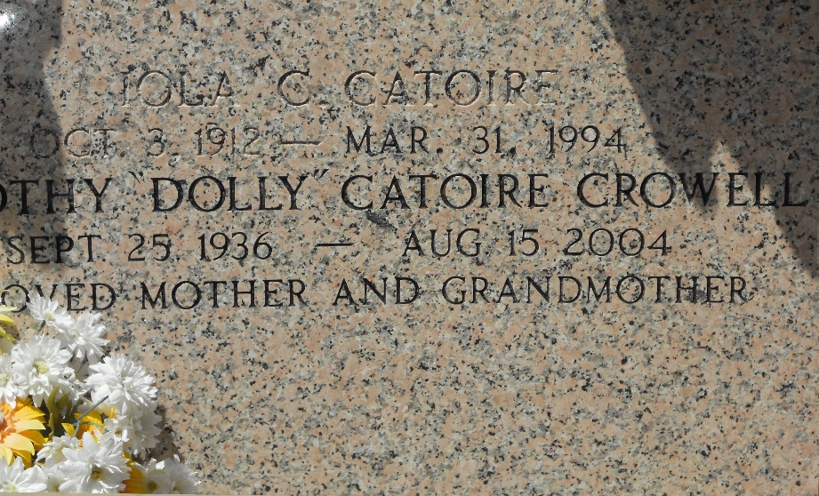

Photo by Team T-Lo

LAPLACE - Dorothy Catoire "Dolly" Crowell, a native of Reserve and resident of LaPlace for 40 years, died Aug. 15.

She was the mother of Kim Mengarelli, Dana Weidman, Keith and Chris Polato, Monique Mixon, and Marcel Madere. She was also the daughter of the late Henry and Iola Catoire, and sister of Loe Ruiz, H.P. and the late Billy Catoire. She is also survived by six grandchildren.

Services were Aug. 18 in the chapel of Millet-Guidry Funeral Home, LaPlace, with interment at St. Peter Cemetery, Reserve.

L'Observateur, LaPlace, Louisiana

Monday, August 23, 2004