Melvin A. De Jean Sr.

November 25, 1913 – May 9, 2006

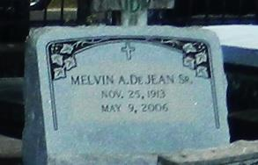

NORCO - Melvin A. DeJean, 92, a native of Lutcher and a resident of Norco, died May 9.  
 He was the husband of the late Inez Simon DeJean by first marriage and the late Grace DeJean by second marriage. He is survived by his children Patricia DeJean Costa, Mel (Carolyn) DeJean and Dennis and Martin DeJean. He is also survived by a sister Ethel DeJean Hayes, 11 grandchildren and 30 great-grandchildren.  
 He was preceded in death by his parents George and Virginia Duhe DeJean and siblings George, Percy, Dudley, Elwood, Roy and Harry DeJean and Gloria DeJean Brignac and Shirley DeJean Knott.  
 Services will be held today at 11 a.m. at Sacred Heart Catholic Church, Norco, with interment in St. Peter Catholic Church Cemetery, Reserve.  
 H.C. Alexander Funeral Home of Norco is in charge of arrangements. Visitation begins at 10 a.m. at the church.

L'Observateur (La Place, LA) - Monday, May 15, 2006

Contributed by Jane Edson