Emile Joseph DeLaneuville

November 6, 1933 – May 14, 2016

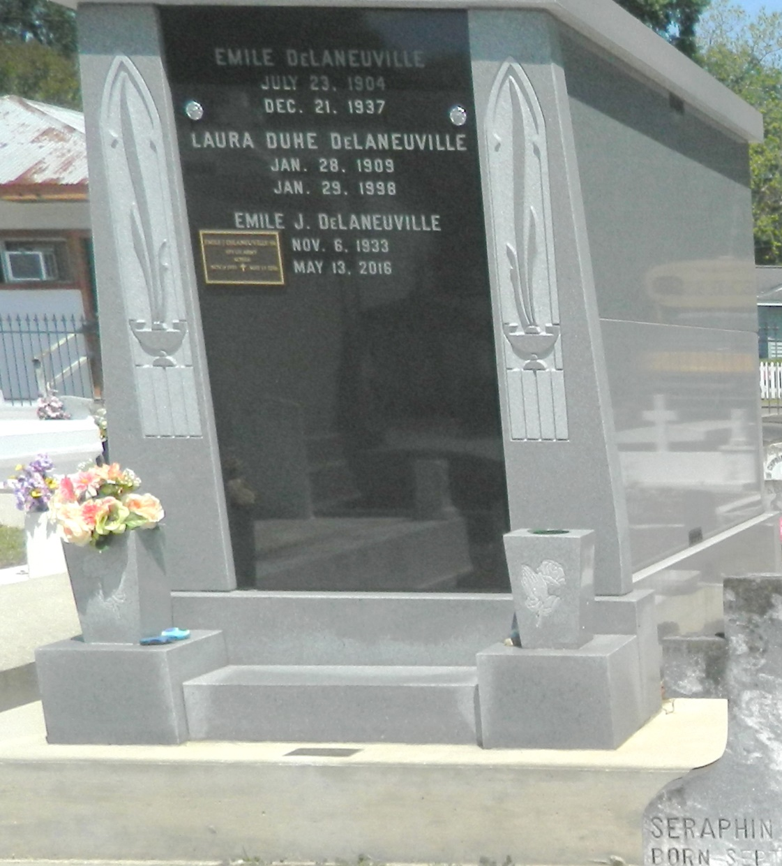

Emile Joseph DeLaneuville,Sr. passed away on Friday, May 13, 2016 in New Orleans, LA at the age of 82. A life long resident of Reserve, LA. He retired from the Shell Chemical Plant in Norco after 36 years of service. He was a veteran of the U.S. Army serving in Korea. Beloved husband of Arlene Gay.  
  
Klibert DeLaneuville married for 56 years (sic). Loving father of Emile DeLaneuville Jr., Sharon DeLaneuville, Steven DeLaneuville (Rise'), David DeLaneuville (Janet). Grandfather of Colette Casso, Justin DeLaneuville and Dane DeLaneuville. Son of the late Emile DeLaneuville and Laura Duhe DeLaneuville and brother of the late Dolores DeLaneuville Dottolo (Tony). Brother in law of Joan Babin (Ray) and the late Wayne Klibert (Kathy).  
  
Relatives and friends of the family are invited to attend the Funeral Mass at St. Peter Catholic Church, 1550 Highway 44 Reserve, LA, on Wednesday, May 18, 2016 at Noon. Visitation will begin in the church at 10:00 a.m. Interment will follow in St. Peter Cemetery. Arrangements by Millet-Guidry Funeral Home. To view or sign the online guest book, please visit [www.milletguidry.com](http://www.milletguidry.com/)

Times-Picayune, The (New Orleans, LA) - Saturday, May 14, 2016

Contributed by Jane Edson